In This Issue

- April-May Orchard Tasks
- Walnut Blight Management
- Walnut Mold and How to Manage It
- Irrigating Walnut Trees in 2025
- Ag Finance Workshop Recap
- SWP Baseline Table for Walnut

Submitted by:

Clarissa Reyes
UCCE Farm Advisor
Sutter, Yuba, Butte, Placer Counties
530-433-4301
Walnut Orchard Tasks
Becky Wheeler-Dykes, UCCE Farm Advisor, Glenn, Tehama, and Colusa Counties

Irrigation – Spring is a great time to perform regular irrigation system maintenance like checking filters and emitters, replacing/refilling filter media, and repairing broken lines. If you farm in Butte, Tehama, Shasta, Glenn, you can apply for a free irrigation system evaluation from the Tehama Resource Conservation District Mobile Irrigation Lab by contacting Kevin Greer (530) 727-1297 or kevin@tehamacountyrcd.org. If you farm in Yolo, Colusa, Sutter, or Yuba counties you can contact Conor Higgins (530) 661-1688 x 4 or higgins@yolorcd.org.

Before you start irrigating, consider plant water stress (pressure chamber) measurements and soil moisture sensor readings. Ongoing research in the Sacramento Valley has found irrigation can be delayed until June in some years, saving water and pumping costs without negative impacts to yield, size or quality. Please see the article Irrigating Walnut in 2025 in this issue for more information.

Weeds – keep on top of any weeds that get past your pre-emergent herbicide application by applying an appropriate post-emergent when necessary. Make sure to rotate modes of action to minimize the potential of herbicide resistance in your fields. Utilize this chart to find information on site of action group, registration, and uses of common herbicides. Always read and follow the label!

Codling Moth – Deploy codling moth traps in mid-March to determine the first flight biofix. Once the biofix is established, track degree days and continue to evaluate pest pressure for treatment thresholds and timing. Consider using mating disruption, especially in orchards with previous codling moth pressure. Mating disruption should be deployed prior to the first flight. Pest reports for codling moth and NOW are available at sacvalleyorchards.com/pest-reports

Navel Orangeworm (NOW) – Consider putting out NOW pheromone traps for adult males and traps baited with ground pistachio meal for adult females.

Walnut Blight – keep an eye on the weather and consider your orchard’s past walnut blight pressure when timing your first blight spray. Spray as early as bud break or catkin emergence in fields with high blight history and where rain is forecast, following up 7-10 days later with a second spray. Lower risk blocks can be sprayed at 20% prayer stage. Using the Xanthocast model can also help forecast disease risk and time re-treatment intervals.

Bot Canker – Limbs that have been killed by Bot canker are easy to identify between budbreak and full leaf expansion but wait to prune dead wood until rain is no longer in the forecast.

Scale – Monitor for scale crawlers by putting out double-sided sticky tape by early to mid-April if scale has been a problem and you didn’t treat for scale during the dormant season.

Aphids – Begin aphid sampling in May and continue throughout the summer. Collect 5 first subterminal leaflets (one back from the last leaflet) from 10 trees, checking the top surface for dusky-veined aphids and the underside for walnut aphids. Make treatment decisions following guidelines and thresholds here.

Nutrition – If last year’s leaf analysis indicated a zinc deficiency, apply foliar zinc when shoots are 6-10 inches long. This is only worth the investment in orchards with known deficiency.
Apply the first round of nitrogen fertilizer in May, not before. Walnut trees only use stored nitrogen the first month after leaf-out, meaning N applied before May will likely be leached by rain and/or irrigation. Walnut tree nitrogen use is fairly steady over the growing season. Evenly dividing nitrogen applications in 3 to 4 doses between May and mid-August will improve N uptake compared to 1 to 2 applications.

Frost Protection – Watch weather reports for any spring freeze events. If a freeze is predicted, mow groundcover to less than 2” to maximize the heat retention of the soil. Make sure soil is moist and consider running sprinklers during the frost for additional protection.
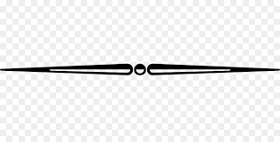
Walnut Blight Management
Jaime Ott, UCCE Farm Advisor, Tehama, Shasta, Glenn, and Butte Counties

According to Dr. Jim Adaskaveg, UC Riverside professor who has been studying walnut blight for decades, these are the most common mistakes growers make in their blight control program:

First spray too late | Wrong TIMING
Half sprays from every-other-row application | Poor COVERAGE
Poor spray coverage both by air and ground | Poor COVERAGE
Not tank mixing | Wrong MATERIAL
Material rates too low | Wrong MATERIAL
Using a weak material in high blight potential orchards | Wrong MATERIAL

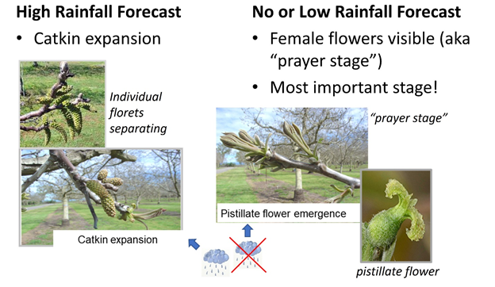

Figure 1. In orchards with low levels of walnut blight in the last few years, the weather during bloom is the most important factor when deciding when to start your blight spray program.

Walnut blight is caused by the bacterium Xanthomonas arboricola pv. juglandis (Xaj) and is one of the most devastating diseases in walnut orchards. Xaj overwinters in bud scales and infects young flowers and shoots as they emerge in the spring. Rainy weather favors infection, and nearly any young tissue exposed to water (rain, dew, sprinklers) is susceptible.

Spray timing is crucial for effective management
Blight sprays protect young tissue from infection. It is critical to get the timing right on your spray: too early and the protection has worn off when it’s needed the most, too late and the infection has already happened. While weather is wet (conducive to disease), sprays will be needed every 7-10 days to protect new tissue as it emerges.

If rain is predicted during early bloom or the orchard has a history of high disease pressure, start spraying at catkin expansion. | If little or no rain is predicted during early bloom or the orchard has had very little walnut blight in past seasons, start spraying at prayer stage (when the female flowers emerge).
Spray coverage is crucial for effective management
The materials we use to manage walnut blight work as a protective layer: if tissue isn’t covered in your material, it is not protected from infection. Most of these materials are contact materials: they don’t move in the plant at all. Achieving excellent coverage should be your goal to make the most of the time and money you are investing in your sprays. Calibrate your sprayer to make sure you are getting the coverage you need for the protection you are counting on. Based on our experience in the field, half sprays just don’t provide good enough coverage for effective disease control.

Choosing the right mix of materials is crucial for effective management
No single material effectively controls walnut blight. Historically growers have relied on copper, but copper resistance is common in Xaj populations throughout the state. In 2024, over 64% of the Xaj isolates Dr. Adaskaveg’s lab collected had genes for copper resistance. This resistance can be counteracted by adding mancozeb (Manzate) or dodine (Syllit) to the spray tank along with copper. Research by Dr. Adaskaveg has shown that similar levels of disease control can be achieved with much lower amounts of copper when mixing mancozeb, a copper hydroxide product (like Champ, at 32oz/Acre), and a copper sulfate pentahydrate product (like CS 2005, at 27oz/Acre). In this case, 16oz of metallic copper equivalent provided the same level of control as achieved with mancozeb + copper hydroxide at 64oz (32-oz metallic copper equivalent).

We also have access to the antibiotic kasugamycin (Kasumin), which is effective against blight when mixed with dodine, copper, or mancozeb. Kasugamycin is an important material for helping to manage copper resistance in Xaj. It is labeled for use in walnuts up to four times per season, with up to two consecutive applications before rotating to a different chemistry.

See the UCIPM Fungicide and Bactericide Efficacy Table for more information.

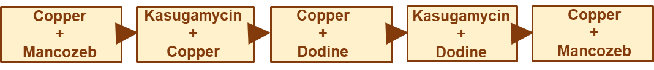
Figure 1. Example of a blight material rotation in a year with high rainfall during bloom and leafout. In this example, a grower would start with a copper + mancozeb spray at catkin expansion and apply each subsequent mixture at 7-10 day intervals.
*Any mention of a pesticide product is for illustration only and is not an endorsement or a pesticide recommendation, simply the sharing of research results. Consult your PCA and always read the pesticide label; the label is law.

Walnut Mold and How to Manage It
Themis J. Michailides & Victor Manuel Gabri, University of California, Davis / Kearney Ag Research and Extension Center

In the last several years, walnut growers in California experienced unusually high levels of mold in their crop. Particularly in 2018, growers in Glenn and Butte counties reported 30-40% mold. Levels of 1-3% mold are considered something the growers expect in a normal year.

Definition of mold
According to the US Standards for grades of walnuts in the shell, mold is one of the seven types of damage which when is attached to the kernel and conspicuous; or, when inconspicuous white or gray mold affects an aggregate area larger than 1 square centimeter or one-eighth of the entire surface of the kernel, whichever is the lesser area.

Characteristics of nuts affecting mold
Initial reports of the 1970s and 80s reported Penicillium spp. causing mold, but in recent years, the predominant fungi isolated from walnut kernels with mold are mainly species of Fusarium and Alternaria. In years with unusually long drought and hot weather Aspergillus niger can also cause mold. Also, in orchards where there is Botryosphaeria and/or Phomopsis canker and blight, Botryosphaeria and Phomopsis fungi can also invade the walnut cavity and cause mold. When isolates of Alternaria and Fusarium fungi were inoculated on walnut fruit, this resulted in mold covering the infected kernels. Back in 1994 and 1995, Drs. M. Doster and T. Michailides cracked about 4,000 walnuts and determined levels of mold after separating them in various categories. In those studies, it was found that nuts had more mold when a) they were infested by the navel orangeworm and/or other insects; b) when nuts were damaged by sunburn; c) nuts had shriveled husks and/or had decay lesion on their hull; d) when the opening of their ostiole was larger than smaller; e) nuts were larger size than smaller size; and f) when nuts stayed on the ground more than 24 hours before harvest (i.e., windfalls, etc.)

Infection and other factors affecting mold levels
After opening mature nuts and examining the origin of the fungal colony as it developed on the kernel, up to 80% of the fungal colonies originated from the stylar end, while up to 30% originated from the stem end. This suggests that a high level of mold from fungal infection occurs at the style of the flower/young developing fruitlet.

To check this hypothesis, samples of walnut flowers were collected and the flower style was plated on agar media. The predominant fungi isolated were Alternaria (up to 38%) and Fusarium (up to 12%). Among the serial inoculations of walnut with Alternaria or Fusarium, the inoculations at the end of April (bloom time) resulted in significantly more infection by Alternaria (57%) or Fusarium (55%) than the water-inoculated control. These results suggest that indeed a high incidence of mold infection starts during bloom of walnut. Infections also can occur at later stage as well, particularly close to and after the hull split stage of fruit.

Depending on the time of infection, infected nuts show different characteristics. The nuts that are infected at bloom, when the mold develops sooner, result in infected nuts with brownish, wrinkled and intact hulls (without any cracks). Nuts that are infected at the early hull-split stage will have cracked (partially split) hulls. Nuts that are infected at a later hull-split stage will have black hulls and entirely split hulls that develop sections connected at the stem end. Of these nuts, more mold was found in the earlier-infected nuts (those with intact, but shriveled hulls and partially cracked hulls) than in the later-infected nuts (nuts that were black and had entirely split hulls) (Figure 1).

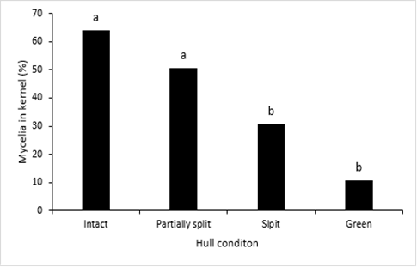
Figure 1. Incidence of fungal mycelia in the kernel of “black” blighted (moldy) by category of various types of brown/black- and green-hull nuts, depending on the condition of their hulls, intact wrinkled brown hulls; partially split (brown) hulls; and black with well split hull sections. (Bars topped with different letters are significantly different according to an LSDA test (P = 0.05).

Mold management
Cultural practices
Although controlling relative humidity in the orchard is not easy, avoid having puddles of water in the orchard to decrease humidity. Also, because Alternaria and Fusarium are airborne fungi, be careful about creating dust, especially during bloom and hull split, to reduce inoculum that can infect flowers and hull split nuts.

Fungicide sprays
One spray with flutriafol (Rhyme) at a rate of 7 oz /acre 1-3 weeks before hull split (HS), or at 20-30% HS, resulted in a 60-70% reduction of mold in a Chandler orchard in Butte Co.

In another experiment in 2023, Chandler trees in a flood irrigated orchard were sprayed with Luna Experience at 17.0 fl oz/acre with three different timings: 1) one spray at bloom, 2) one spray at bloom and one spray 1 week before hull split or 3) two sprays, 3 and 1 weeks before hull split. All treatments reduced blighted (moldy) nuts by 40 to 55%, and there were no significant differences whether the trees received one or 2 sprays.
In 2024, in the same flood-irrigated orchard was treated with different fungicide combinations at different times. One spray with Luna Experience combined with Ethephon applied at 20-30% HS reduced blighted (moldy) nuts the most by 54%. Other treatments reduced mold by 40- 48%: One Luna spray alone at 20-30% HS, one Luna spray 1 week before HS, or Ethephon only spray alone at 20-30% HS. All the spray treatments were significantly lower than the untreated control, but they did not differ between each other.

Also in 2024, in a sprinkler-irrigated Chandler orchard with heavy Botryosphaeria canker and blight, one bloom spray with Merivon, Cevya, or Luna Experience each significantly reduced blighted (moldy) nuts by 43-73%. All the sprays as described in Figure 2 showed significantly lower blighted (moldy) nuts than the untreated control. In this orchard, Botryosphaeria canker and blight was severe, and >75% of the moldy nuts had Botryosphaeria species isolated from them causing kernel mold. The results suggest that a new fungicide (Cevya, FRAC 3) can be added as a tool for walnut growers for the control of Botryosphaeria canker and blight and mold.

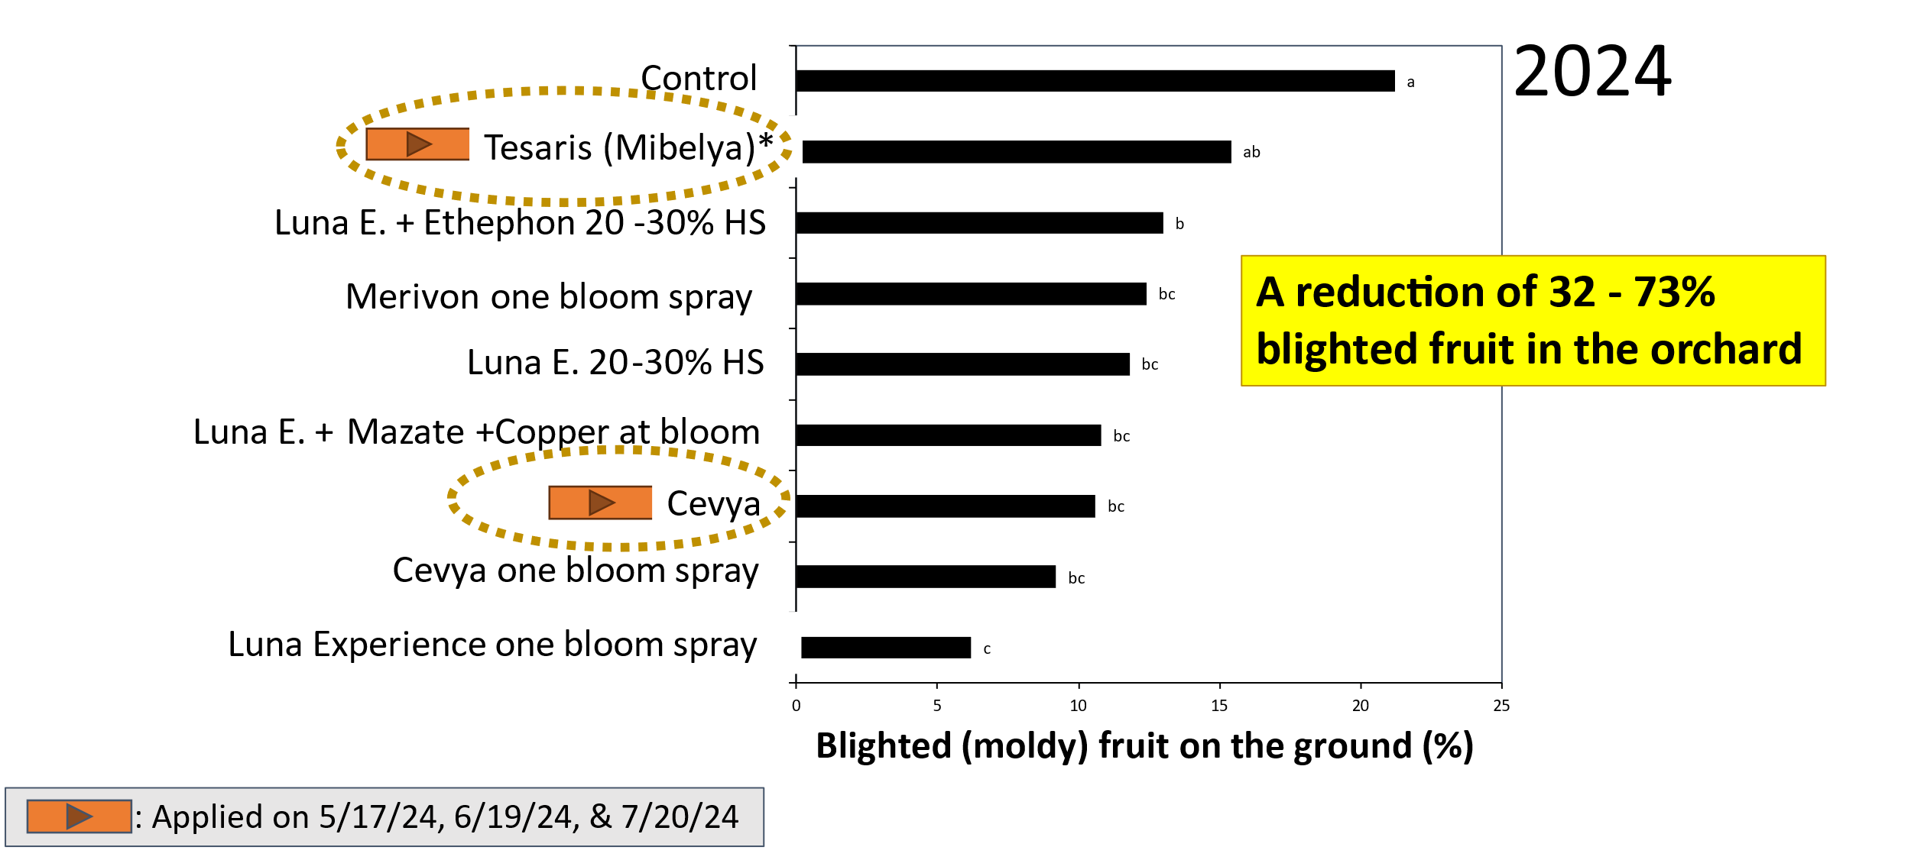

Figure 2. Effect of fungicide sprays on Botryosphaeria moldy nuts recorded in the field after tree shaking in a sprinkler-irrigated Chandler orchard in Butte Co. Columns with different letters indicate significant differences according to an LSD test (P = 0.05).

For more information consult the 2024 Project Report to the California Walnut Board by Michailides et al.

Irrigating Walnut Trees in 2025 – Continuing Research on When to Start
Curt Pierce, UCCE Irrigation and Water Resource Advisor
Luke Milliron, UCCE Orchard Systems Advisor

With the days only just warming and (at the time of this writing) significant rain still falling in the North Sacramento Valley, few are likely to be in any rush to start pumping. Spring heat can come on fast, however, quickly drying the soil surface and raising questions about when to best start replacing “lost” soil moisture with regular irrigations. UC continually researches and updates the recommended best practices for spring walnut irrigation to ensure the healthiest orchards possible and help lower utility costs. This research has shown that, by delaying the start of regular irrigations, it might be possible to irrigate as little as one-half of what was previously thought to be needed, with little to no impact on production (Figure 1).
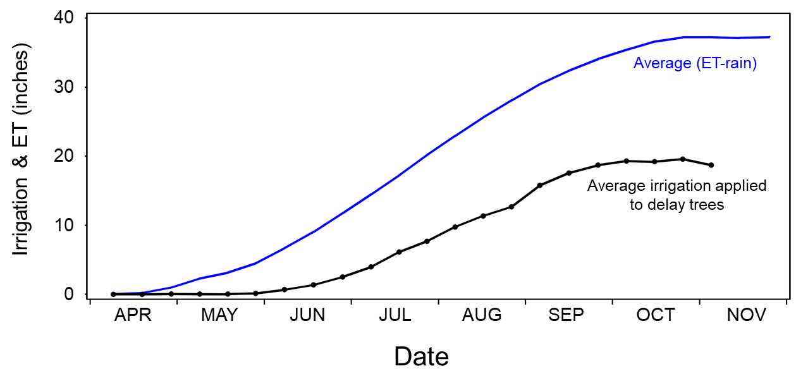

Figure 1: Summary of average orchard water requirement (ET minus rain) and applied irrigation for all delayed irrigation tests to date (2014 – 2020). Averaged over all sites and years thus far, the delay period has been almost two months (indicated by arrow) compared to the start of ET. The total water applied to the delay trees has only been about 50% of the orchard ET need (ET-rain).

We know that walnut is more sensitive to water stress than some other tree crops, but what does that mean? When many folks think of water stress, they think of the stress to the tree that comes from too little water, as in times of drought or extreme heat. Of course, water stress can, and often does, come from too much water as well. We often see this play out at the tail ends of the wet season, with walnut orchards underwater for extended periods just as they emerge from dormancy in spring.

While the primary concern from these events may be disease, such as Phytophthora, when the water is not actively flowing, waterlogging of the roots can result from the lack of oxygenation in the water. However, water stress in the root zone isn’t confined to extreme flood events. The most active growth period for new roots, those best able to uptake water and nutrients, is in spring and early summer. As they grow into new soil, these roots form the scaffolding for additional root growth throughout the growing season. Too much soil water early in the spring can suppress the most significant growth of these roots – limiting water and nutrient uptake potential during the hottest and driest weeks of summer, as well as causing tip burn, leaf damage, and dark kernels. When compared to other area tree crops, walnut is simply more sensitive to water stress, and therefore more difficult to irrigate “just right.”

Effectively managing irrigation in walnut, including when to start, is easiest when employing the pressure chamber, which measures one indicator of the tree’s “stress level” – the stem water potential (SWP). While there are countless differences between operations, the economics of owning a pressure chamber can quickly pencil-out whether owning one outright, cost-sharing on a unit with others, or adding it to the list of services from your PCA. Savings on power bills from $50-$100 per acre can be reasonably expected with effective, plant-based irrigation management, such as with SWP monitoring.

UC has developed a table of baseline values (included with this issue) that can be used together with a pressure chamber to help determine when best to irrigate. Continuing research done by UC has shown that waiting until walnut trees show a SWP value with the pressure chamber that is slightly drier (2-3 bars drier or more negative) than the fully irrigated “baseline” SWP value. Of course, your local UCCE advisors are here to help if you do not have access to a pressure chamber or other means to determine SWP in your orchard. We can also help with equipment and scheduling training for those of you who have access to a pressure chamber but are not comfortable using it for irrigation scheduling.

Beyond the pressure chamber? Despite showing that it provides a great return on investment, we know some growers struggle to get on board with the pressure chamber. Whether it’s the cost of purchasing one or the skilled labor at midday required for its use. Researchers at UC Davis have conducted preliminary field tests in 2024 using an optical dendrometer that showed a high correlation with the pressure chamber. However, these are early days in that research, and we don't yet have a silver bullet solution for automated plant water stress monitoring in walnut. For now, the pressure chamber remains the only way to reliably irrigate to the plant’s needs in walnut.

From the Butte County Farm Bureau Ag. Finance Workshop:
Some Financial Metrics You Should Know
Domena A. Agyeman, UCCE Economic Advisor; Butte, Glenn, and Tehama Counties

Managing farm finances can be challenging—especially for small growers who cannot afford to hire experts. However, understanding key financial statements and metrics is crucial for making informed decisions and ensuring long-term business sustainability. Many growers who completed my economics needs survey reported familiarity with various financial management topics. However, fewer than half expressed strong confidence in areas such as creating financial statements, cash flow management, recordkeeping, farm investment analysis, and benchmarking, among others—highlighting key gaps in confidence and the need for more educational resources (See fig. 4 of the economics needs report).
To help small farm businesses strengthen their financial management skills, the Butte County Farm Bureau (BCFB) hosted an Agricultural Finance Workshop on February 20, 2025, at its Chico office. Moderated by BCFB’s Executive Director, Colleen Cecil, the event featured a panel discussion on grant writing and loan servicing, with experts from 3CORE, Morrison, Tri Counties Bank, Small Business Administration, and California Farmlink. Additionally, business financial expert Tim Peters from Morrison provided valuable insights into essential financial statement reports and metrics that every farm business should know.
Tim emphasized the importance of understanding balance sheets, income statements, and their components. The balance sheet provides a snapshot of a business’s financial position at a specific point in time, while the income statement helps assess its performance over a period. He highlighted key financial metrics and ratios that offer insights beyond what financial statements alone can reveal. Below are some of the metrics discussed:
- EBITDA (earnings before interest, taxes, depreciation, and amortization) margin (gross margin / revenue): a profitability ratio that measures a company's operating profit as a percentage of its total revenue, before accounting for interest, taxes, depreciation, and amortization. It shows how efficiently a company generates earnings from its operations.
- Debt-to-equity ratio (total liabilities / total equity): a leverage metric that measures the proportion of a company's debt compared to its equity. It indicates the level of financial risk by showing how much of the company's financing comes from creditors versus owners.
- Current ratio (current assets / current liabilities): a liquidity metric that assesses a company's ability to pay its short-term liabilities with its short-term assets. A ratio above 1 suggests good short-term financial health.

These metrics help assess a farm business’s financial health by evaluating its profitability, reliance on debt, and overall solvency. It is important for growers to become familiar with these metrics and strive to achieve their desired levels because lenders and potential investors consider them in financing decisions. Examples of preferred financial benchmarks include:
- Debt-to-equity ratio: between 0.5 and 1.5
- EBITDA margin: over 10%
- Current ratio: at least 1.25
Understanding and maintaining strong financial metrics can improve a grower’s access to credit and investment opportunities. See this handout for more details on the financial statements, key metrics, and their desired levels discussed at the workshop.
The panel discussion reinforced the importance of financial literacy for farmers. Mark Edwards (Senior Vice President for Commercial Lending at Tri Counties Bank in Chico) and Dan Zuno (Relationship Manager at 3CORE) both emphasized that small farm businesses are always welcome to seek guidance and that their institutions are committed to working with them to find tailored financial solutions. They also highlighted the benefits of farmers coming prepared with some basic financial records, as this can streamline the lending process and improve access to financing.
For small businesses located in Butte, Tehama, and Glenn counties, 3CORE offers a no-cost technical assistance program designed to help small businesses improve their marketing strategies and financial management skills. This program can be valuable for growers who may not know where to begin or who lack organized financial records. Through one-on-one guidance and practical tools, growers can gain the knowledge and support needed to improve their recordkeeping, assess their financial health, and position themselves for better financing opportunities. A summary of the benefits of 3CORE’s technical assistance programs is provided here.
In addition to these resources, walnut growers can use a user-friendly spreadsheet from UC Cooperative Extension to track their costs and returns (Access the spreadsheet here). Once downloaded, you can input your own cost information in the yellow-shaded sections of the third sheet titled ‘costs per acre – user input.’ The results will automatically populate in the ‘cost per acre – output’ sheet. This resource can be helpful for growers looking to better organize their expenses and financial records, as well as assess the profitability of their operations.
Managing farm finances is an ongoing learning process. However, by understanding key financial statements, tracking important metrics, and leveraging available resources, growers can strengthen their financial health and improve their borrowing potential.

Up-to-date orchard-related events, news & articles from
UC Cooperative Extension farm advisors from the Sacramento Valley.



Visit: sacvalleyorchards.com

