Fall & Winter Almond Orchard Management Considerations
In This Issue

- Post-Harvest Clean up
- Zinc and Boron review
- Almond Variety Planting Trends
- Potassium Management

Franz Niederholzer
UCCE Farm Advisor
Sutter, Yuba, Colusa Counties

Drew Alonso Wolter, UCCE Junior Specialist Horticulture Intern, UC Davis Graduate Student
Franz Niederholzer, UCCE Orchard Advisor, Sutter/Yuba and Colusa Counties
Katherine Jarvis-Shean, UCCE Orchard Advisor, Sacramento, Solano and Yolo Counties

Post-harvest orchard clean-up/monitoring
- Survey orchard for mummy nuts. If more than 2 nuts per tree remain, plan to knock off and destroy mummies by February 1st to reduce navel orangeworm. Nuts stuck to the tree well after harvest may indicate hull rot or excessive boron. If hull rot is indicated, make a note to revise/reevaluate irrigation and nitrogen management practices in May and/or June to help manage hull rot next year. If you’d like more information on symptoms and signs of hull rot visit: ipm.ucanr.edu/agriculture/almond/hull-rot/
- Prune out damaged branches, but avoid pruning immediately prior to rainfall event. This is especially true in young orchards. Disease spores are spread in rain events and pruning wounds are a key entry-point for these infections. Recent research has found that Topsin-M is a highly effective pruning wound protectant against several canker pathogens including Cytospora and Botryosphaeriaceae (“Bot”) species.
- Scout for weeds after the first fall rains. Look for late summer weeds that escaped this year’s control and winter annual weeds that are just emerging. UC IPM has a late fall weed survey form (ipm.ucanr.edu/PMG/C003/almond-fallweed.pdf) that can help. The UC Weed ID Tool (weedid.wisc.edu/ca/weedid.php) may also help. See article in this newsletter for more information.
    - Winter weed control. Pre-emergence herbicide (combined with a post-emergence burn-down material, if winter weeds have already germinated) should be applied shortly before a moderate rain event (0.25”) to move material into the soil. Avoid application prior to a large rain event (> 1”), which can move the product too deep into the soil for good weed control. Avoid spraying root/trunk sucker leaves with any spray containing systemic herbicides such as glyphosate (Roundup, etc.), since those herbicides can enter the tree and cause damage next spring.
Pest & Disease
- Sanitize your orchard, if needed. If you find more than 2 mummy nuts/tree when doing the mummy survey mentioned above, sanitize your orchard by shaking all trees/all varieties later in the fall or winter to get mummies out of the trees. If shaking doesn’t get mummy numbers down to 2 nuts per tree or less, use a hand crew (polling crew) to get to the mummy target you are using. [In the central and southern San Joaquin Valley where NOW pressure is very high, the target is 1 mummy for every 5 trees.] This is a critical step to managing worms next year in your orchard.
- Check mummy infestation. Once the mummies are on the ground, check 20 per block for live NOW. The higher the number, the more the pressure should be next year. The % infested mummy number is part of the information you and your PCA will need to help keep damage as low as possible next year.
- Check dormant spurs for scale, mite eggs and scab sometime between mid-November and mid-January. For more information on sampling visit: ipm.ucanr.edu/PMG/r3900211.html.
- Watch for shot hole fruiting structures in leaf lesions after fall rains begin. If fruiting structures producing spores are present in leaf lesions in the fall, there is a greater risk of shot hole development the following spring. A foliar zinc sulfate nutritional spray applied in early November may hasten leaf fall and reduce shot hole inoculum. For more information on shot hole symptoms and signs visit: ipm.ucanr.edu/PMG/r3100211.html.
Nutrition
- Consider a fall nutrient spray. Both boron (B) and zinc (Zn) can be absorbed into leaves and translocated within almond trees. Check hull sample B results and July Zn leaf levels to help determine if a foliar spray of either or both nutrients is needed. For more information, see the article in this newsletter.
- Planting a cover crop to improve soil, provide pollen to bees, and/or reduce runoff? Get it in the ground by the end of October for best stand establishment. For information on cover crop seed selection visit: sacvalleyorchards.com/almonds/horticulture/cover-crop-seed-selection/.
- Apply banded potassium to the soil if that is part of your fertility management plan. For every 1,000 lbs of almond kernels harvested there are 80 lbs of potassium removed from the orchard or captured in new growth. For more information, see the article in this newsletter.

Zinc and Boron Review
Franz Niederholzer, UCCE Farm Advisor, Colusa and Sutter/Yuba Counties
Urgent and important tasks are priorities in any business. What orchard nutrition tasks are urgent and important given the limited time and energy before leaf drop?
Zinc, and where needed, boron:
Zinc and boron are important elements for the beginning of growth in the spring and the successful nut set. Specifically, zinc is needed to ensure timely bud break and shoot extension and boron is needed for pollen germination and pollen tube growth. Because only small amounts of these nutrients are needed compared to nitrogen and potassium, a single foliar spray can deliver needed Zn and B at bloom. The fall is an excellent time to make this spray to orchards with healthy canopies because the nutrients can be stored overwinter in the tree. Zn and B can be applied in pink bud sprays, but impacts of these nutrients on bee health are largely unknown. In addition, B sprayed after flowers open at full bloom can reduce nut set, not improve it. Bloom timing variation between varieties makes pink bud a tough target to hit for all varieties without spraying at least one variety at full bloom.
Zinc (Zn) is critical for timely bud break and expanding shoot growth, so adequate Zn must be present in deciduous tree crops at bud break. Since Zn is readily tied up in soils, a foliar treatment is the most cost effective Zn fertilization method if summer leaf levels are at or below 15 ppm Zn. If ziram or foliar zinc product was applied before summer leaf samples were taken, leaf Zn values will show Zn in and on the leaf and will not give an accurate measure of Zn status. If the leaf samples were contaminated in one of these ways, growers must then decide if a fall zinc treatment will be worth the cost (roughly $5-20/acre for zinc sulfate) without knowing if the orchard is really deficient or not. Waiting for foliar Zn deficiency symptoms after bud break means any corrective spray will be too late.
If a decision to spray is made, carefully consider the rate to use. A fall Zn spray at a high rate (for example, 20+ lbs. zinc sulfate/acre) can defoliate trees while delivering needed Zn. This has been a standard late fall (November) practice for many years in California almonds. Recent research in stone fruit showed that lower rates of zinc sulfate (5 lbs/acre) applied in October were as effective in getting Zn into the trees as later sprays (November) at higher rates without damaging leaves. Trees benefit from natural leaf drop (without a high zinc rate) through recycling of leaf N that stay in the tree and is stored for use at bloom. If you choose to use a high rate of zinc sulfate plus boron, research shows that the boron gets into the tree before the leaves drop.
Boron (B): A fall B spray can increase almond yield by hundreds of kernel pounds per acre when hull boron (B) analysis show low to adequate orchard B. This yield bump has been documented in multiple studies by UC researchers. The decision to use a fall foliar B and at what rate be based on harvest hull analysis (see table below).

Orchard Boron Status | Hull Boron (at harvest)
Deficient | <80 ppm
Adequate | 80-150 ppm
Toxic | >300 ppm

When harvest hull B levels are less than 150 ppm, the recommended rates are 0.2-0.4 lbs. B/acre – equivalent to 1-2 lbs. Solubor®/acre - as a foliar spray targeting a full, healthy canopy either during the fall or at pink bud. Note: fall soil-applied B fertilizer doesn’t increase plant B levels until after petal fall the next year but can correct deficiencies for several years. Growers with <120 ppm B in hulls on a regular basis may want talk with their CCA to look at soil application(s) of B in the growing season.
Don’t expect to change orchard B status with a fall spray. A 2000 kernel lb. /acre almond crop removes 0.4 lbs. of B from the orchard; equivalent to 2 lbs. Solubor®/acre.
Tank mixes: In UC research, 0.4 lbs. of B as sodium borate and 20 lbs. of zinc sulfate mixed in 100 gallons of water produced a beige cloud in the spray solution. This cloud didn’t clog spray filters or nozzles, but reduced flower B levels compared to just B in the spray tank. Lowering the solution to pH 5.0 with organic acid (not phosphoric acid) before adding Zn and B eliminated the haze and produced flower B levels the same as when B alone was applied. Tank mixing the same rates of B and Zn with the right tank chemistry defoliated trees and increased flower B the next year.
A fall foliar nutrient spray in most growing regions of the Sacramento Valley should include zinc and/or boron to make sure the nutritional status of buds allows the best nut set that the bees and the weather will allow. It could mean several hundred more pounds of kernels per acre in a low B orchard. This is the critical post-harvest nutrient task in Sacramento Valley almond orchards.

Potassium management for sustained almond yields
Katherine Jarvis-Shean, UCCE Orchard Advisor, Sacramento, Solano and Yolo Counties
Joseph Connell, UCCE Farm Advisor Emeritus, Butte County
Patrick H. Brown, UC Davis Professor of Plant Sciences

Adequate potassium is critical to sustained yields in an almond orchard. There are many approaches to providing almond trees with the potassium they need, depending on your local climate conditions, orchard infrastructure and budget.
Why does potassium matter?
Potassium (K) is important for helping plants move and store energy, regulate water loss, grow, flower and fruit. Almonds are particularly K hungry crops. UC Davis and UCCE research found that inadequate potassium decreased yields by increasing spur death and the percent of spurs that had flowers, and thus set nuts.
Following a heavy cropping year, spur survival was 11% lower in potassium-deficient trees (decreasing from 59% to 48%). Of bearing spurs that survived, fruiting spurs decreased from 48% to 40% (the rest produced leaves but not flowers). If spurs had been vegetative the year before, 86% of the spurs on the high potassium trees set fruit, whereas only 75% set fruit in the low potassium trees. The lower spur survival may be related to decreased spur carbohydrate levels. Measurements in the same trial found whole-tree leaf light interception and per-leaf photosynthesis was lower in the low K trees.
All this adds up to the fact that low K will have a carry-over impact on orchard yield. Low K decreases yields the following year by decreasing the number of flowering (and thus fruiting) spurs where the tree will set nuts. Trees which received no potassium in a heavy crop year (4,040 lbs/ac across all treatments) yielded 15% lower the following year, compared with trees which received adequate potassium.
How much potassium do almond trees need?
Research by the Brown lab at UC Davis found 80 lbs of K are exported for every 1,000 kernel lbs of almonds harvested, including the hulls, shells and kernels. 45-61% of this K accumulated in the fruit in the first three months (86 days) after full bloom.
How can you know if trees are getting enough potassium?
Visual Symptoms. If trees are deficient enough in potassium to show leaf symptoms, tree health and yield are already being impacted. While it’s better to rely on leaf analysis to manage potassium, it’s still good to know the visual symptoms of inadequate K. Potassium deficient almond trees show leaf symptoms in the spring if the deficiency is severe but by early summer even milder deficiencies can produce symptoms on heavily cropped trees. If soils are very wet and cold, when first leafing out, potassium deficient trees appear pale in color and have small leaves with little new growth. Once new shoots are growing in April and May, pale, potassium deficient leaves roll into a boat shape and develop tip and marginal scorching. This classic symptom is seen in the tree tops on leaves in the middle of new shoot growth.

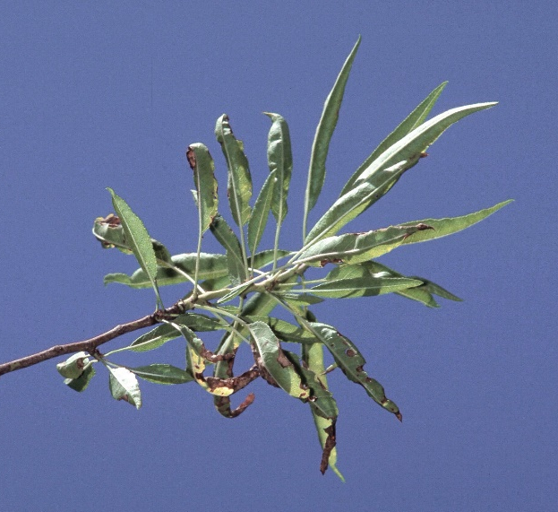
Figure 1. Once new shoots are growing in April and
May, pale, potassium deficient leaves roll into a boat
shape and develop tip and marginal scorching (photo: UC IPM).

Leaf analysis. Because potassium deficiency can have a significant impact on yield before symptoms of deficiency are visible, leaf analysis is an important tool for monitoring tree potassium status. Leaf samples collected in July are useful for evaluating K levels since leaf tissue levels are relatively stable at that time of year. K levels above 1.4% are considered adequate. UC research was unable to show any yield benefit of pushing leaf potassium much above this adequate level. Some research suggests that too much potassium interferes with uptake and use of calcium and magnesium. However, keeping trees a little above 1.4% may make sense. Leaf analysis results are an average of all sampled trees, so if results land squarely at the 1.4% adequate level that means some trees are above that level and some are below. Overshooting 1.4% will ensure that more trees are above the adequate threshold. Higher than adequate levels will also help provide “back-up” for heavy set years, which may be especially important to sprinkler irrigated orchards where in-season fertigation to meet higher than usual potassium needs is not effective.
What’s the Best Source of Potassium?
Potassium can be applied to the soil, be injected into a drip irrigation system (fertigation) or be applied through foliar sprays. Which approach is “best” for a particular orchard will depend on the soil, rainfall, irrigation system, existing potassium and chloride levels, and budget? Potassium ions (K⁺) are readily adsorbed to the negatively charged clay particles in the soil, which then makes them only slowly available to the tree. In soils rich in vermiculite clays, fixation can be rapid and nearly irreversible. Because of this, soil-applied potassium is often concentrated in a band, to overwhelm the potassium-adsorbing capacity of the soil in that small strip. In-season fertigation manages this fixation by concentrating potassium in the wetting zone of a micro- or drip irrigation system. Foliar sprays circumvent this fixation problem by cutting out the soil “middle man” and applying the potassium directly to the tree.
Given enough potassium, and enough water in the right place to move it into the soil, the source rarely makes a difference in yield, according to UC research in the southern San Joaquin Valley and earlier UC work at the Nickels Soils Lab at Arbuckle. Common forms of potassium fertilizer are potassium sulfate (K₂SO₄, “SOP”), potassium chloride (KCl), potassium thiosulfate (KTS) and potassium nitrate. In the San Joaquin Valley, a Brown Lab trial compared winter banded SOP, winter SOP plus in-season (fertigated) KTS, and in-season KCl. When application rates were 30-80% higher than demand, potassium source did not impact yields. In the Nickels trial, winter banded SOP, in-season SOP, in-season MKP (mono-potassium sulfate) and in-season KTS were compared. At Nickels, banded SOP in a single-line drip irrigated orchard increased leaf K significantly less than other potassium sources.
If you’re confused by the nomenclature, blame Medieval Latin! You might be asking, “If the symbol for potassium is K, where’s the K in SOP?” SOP is short for “sulfate of potash”. Before potassium was mined, it was leached out of burnt plant matter. As far back as early medieval times, ashes were soaked in a pot, and then the water was boiled down to concentrate what we now know was leached potassium, for use in a variety of processes, like soap making and textile bleaching. Hence, “pot-ash”. The symbol K comes from kalium, the Latin word for plant ash, which itself was derived from al-qalyah, which is Arabic for “plant ashes”.
Many growers combine multiple approaches to meet their tree’s potassium needs, for example supplying some potassium through fall banding and supplementing with in-season drip fertigation.
Fall Banded Soil Applications. Historically, banding SOP has been the standard practice on much of the almond acreage in the Sacramento Valley. The relatively high rainfall and more common heavy soils (which don’t leach K) in this region makes this a viable practice. With the widespread adoption of micro-irrigation systems and the increased productivity of almond orchards, growers are increasingly adopting more frequent and more targeted K practices. Banding is still well suited to full coverage irrigation systems in which direct fertigation of K is ineffective.
SOP is the most commonly used soil-applied source of potassium. KCl has also been used for soil applications and if chloride (Cl) can be reached on deep well drained soils to prevent Cl buildup, it can meet K needs. Because of the need for rainfall or sprinkler irrigation to move banded SOP or KCl into the soil, the fall banding approach may not be efficient in lower rainfall zones, and certainly is unlikely to be appropriate for much of the San Joaquin Valley. In drip and micro- irrigated orchards, banded potassium outside the wetted root zone, misses the target and is unlikely to be fully available.
In-Season Fertigation. Injecting K through in-season drip irrigation is also very effective because the amount of K per wetted area is very high, potassium fixation is minimized and potassium penetrates into the most active root zone of the tree. There are numerous sources of potassium that are injectable, including KTS, high purity, finely ground SOP, KCl and potassium nitrate. Drip irrigation is a very efficient potassium delivery system. Injecting through micro-irrigation can also be effective when wetted area is concentrated.
Spring foliar applications. Potassium deficiency can also be corrected by foliar sprays through the growing season when sufficient material is applied. Potassium nitrate and KTS are common sources. Other sources include potassium carbonate and many foliar blends. While this approach is a direct and efficient means of K delivery, foliar K is more expensive than soil applied K. In addition, only a small portion of a season’s potassium needs, 5-10 lbs K, can be taken up by the leaves per application. Thus, foliar sprays are most suited to augment an existing potassium management program, particularly in a year with a heavy set.

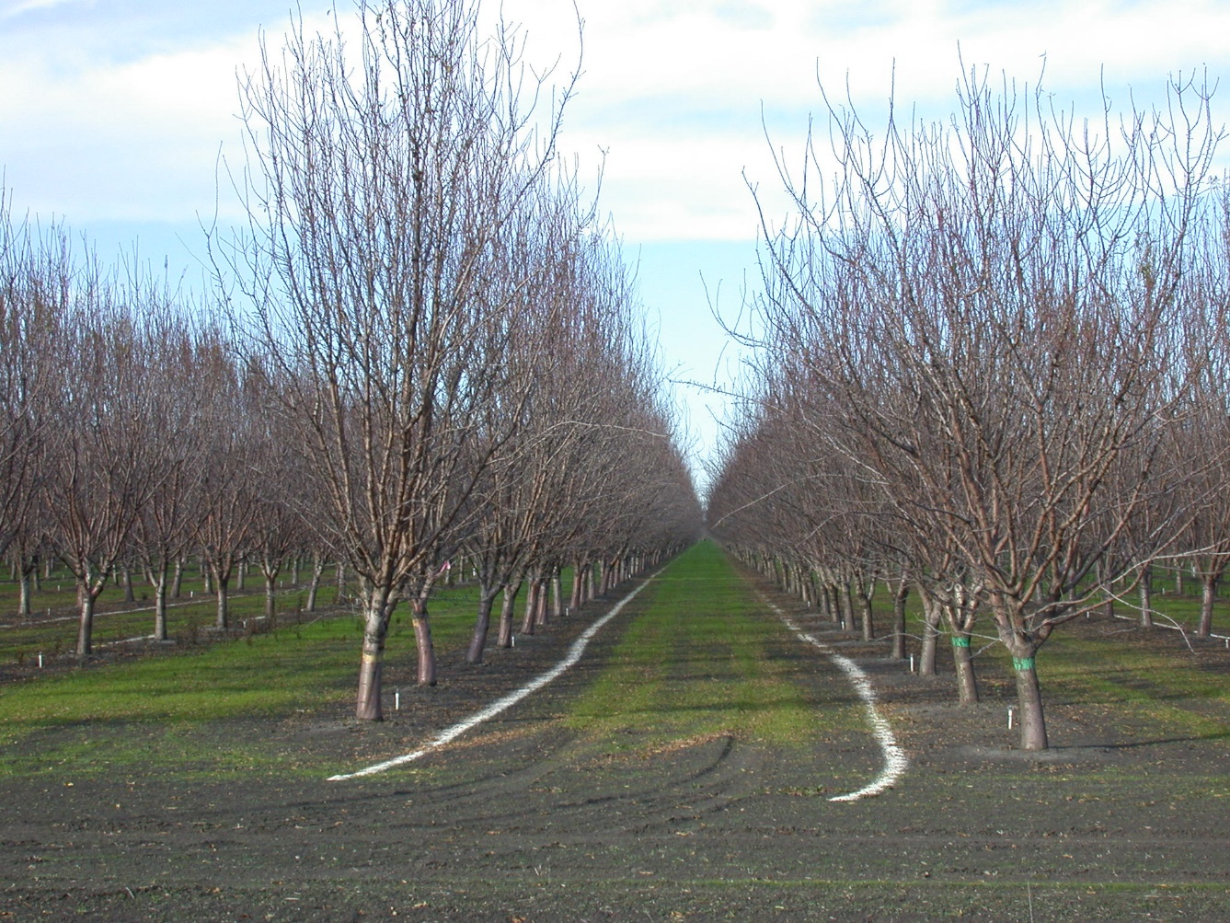
Figure 2. Dormant season band applications of potassium sulfate to every other middle in a non-tilled orchard.

Almond Variety Planting Trends
Franz Niederholzer, UCCE Farm Advisor, Colusa and Sutter/Yuba Counties

A new almond planting should last at least 20 years. With the right varieties, a new almond orchard should be profitable for at least 20 years. Many decisions contribute to successfully meeting that target. One key decision is variety selection. Knowledge of the current and past variety planting trends of almonds in California may be helpful in this decision. Planting trends, total acres planted, as well as acres by variety and county, are released every spring by the CA Department of Agriculture through USDA’s National Agricultural Statistics Service*. Each report includes the last 30 years of planting data.
Current and past planting trends are not absolute predictors of the future commercial success of any variety (Price per pound, market share, etc., should also be considered), but may provide a general idea of future relative production volume by variety. Here are a couple of points I found in reviewing data in the 2018 Almond Acreage Report and the production data in the 2017 Almond Almanac from The Almond Board of California**.
- The seven varieties reported planted at > 5% of the total planting in 2007 (Figure 1) produced 83% of the total crop in 2017 (Table 1). The percentage of the crop produced by those varieties was in the same ranking as the % 2007 planting. [There is a slight change for the state production reporting in 2018, with all Butte reported with Butte/Padre and Wood Colony joining the list of varieties with yield separately reported.]
- Few varieties survived/thrived over the past 30 years. From 1990 to 2018, 33 almond varieties are listed in the 2018 acreage report, yet only 7 varieties are major producers in 2017 and all those 7 were commercially available in 1990. Ten of the 33 varieties listed in the 2018 acreage report were not reported planted in 2018. Varieties come and go but few have staying power.
*****************************************************************************
Table 1. Percent production by variety in California, 2017 and 2018. Data are from the 2018 Almond Almanac**. Production is measured in pounds.

Variety | 2017 % lbs | 2018 % lbs
Nonpariel | 38 | 41
Monterey | 15 | 16
Butte/Padre | 11 | 16
Carmel | 7 | 6
Butte | 5 | combined w Butte/Padre
Fritz | 5 | 4
Wood Colony | Not reported separately | 4
Remaining varieties | 17 | 13

Figure 1. Almond nursery tree planting trends, 2005 to 2018. From top to bottom, the legend reads highest to lowest percentage of the listed varieties for 2018. Data Source: 2018 Almond Acreage Report from CDFA*.
*nass.usda.gov/Statistics_by_State/California/Publications/Specialty_and_Other_Releases/Almond/
**almonds.com/processors/resources/almond-almanac

Increase Your Return on Investment with Post-Harvest Weed Scouting

Drew Wolter, UCCE Junior Specialist Horticulture Intern, UC Davis Graduate Student

Why scout for weeds?
While weeds are present in every orchard, there is variation in the species composition and the density of each population from orchard to orchard. Scouting for weeds is the basis for a good Integrated Weed Management (IWM) plan. Information gathered from weed scouting allows growers to:
- Evaluate the current year’s weed control program
- Discover weed stands before they spread throughout the orchard
- Adjust control practices for the following year
- Select the best control option for species of concern, such as:
  - Choosing appropriate herbicide for species
    - Identifying areas for possible spot treatments
  - Selecting best cultivation method for weed stage
  - Where to alter cultural practices to target weed life cycles
Post-harvest scouting offers an opportunity to evaluate the current year’s orchard floor management plan, allowing you to see what weed species have escaped the year’s management plan, where they are, and how severe the infestation may be. These are all valuable pieces of information, which help design a management program to meet the specific needs of the orchard from year to year.
Keys to Scouting
Most weed species are much more challenging to manage as they mature. Because of this, post-harvest scouting should start early and be repeated a couple of times throughout winter, in order to catch weeds when they are young. Herbicide applications targeting mature weeds are often minimally effective, resulting in a less successful program and increased management costs. Three keys for successful scouting:
- Record weed infestations and use a map/GPS to show areas of escaped weeds. For a weed scouting template and additional information visit: ipm.ucanr.edu/PMG/C003/almond-fallweed.pdf
- Accurately identifying weed species is crucial for effective management because herbicide recommendations, mechanical and cultural control strategies vary depending on the species. While some species can look similar, they may have drastically different management requirements.
- Look out for different weeds in different management zones. A good place to start is by checking in the tree rows to evaluate the effectiveness of any previous herbicide applications. Check the ground cover in the row middles for any perennial seedlings. Check orchard borders and at the ends of rows where new species may be introduced.
Herbicide resistance
With the growing number of herbicide resistant weeds in California orchards, control of escaped weeds can considerably reduce the cost of an annual orchard floor management program. For example, spot treating two acres of glyphosate resistant palmer amaranth with a tank mix of Glufosinate and Gramoxone is much more affordable than trying to control it over the entire 50-acre block. There are currently thirty confirmed herbicide resistant species in California; for the complete list visit: ucanr.edu/blogs/blogcore/postdetail.cfm?postnum=29069. Scout now so you can spot treat, rather than having an orchard full of herbicide resistant weeds in the future.

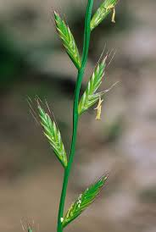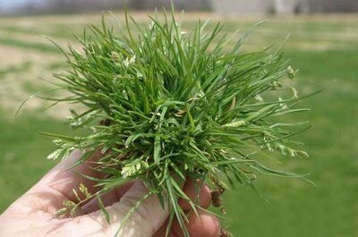
Fig 1. Italian ryegrass (Left) is resistant to both Glyphosate and Glufosinate. Annual bluegrass (Right) is resistant to Glyphosate.

For more information on herbicide resistant weeds, species identification and control options please visit the UC Davis Weed Research and Information Center (https://wric.ucdavis.edu) AND ipm.ucanr.edu/PMG/r606700411.html

ANR NONDISCRIMINATION AND AFFIRMATIVE ACTION POLICY STATEMENT FOR UNIVERSITY OF CALIFORNIA May, 2015. It is the policy of the University of California (UC) and the UC Division of Agriculture & Natural Resources not to engage in discrimination against or harassment of any person in any of its programs or activities (Complete nondiscrimination policy statement can be found at http://ucanr.edu/sites/anrstaff/files/215244.pdf. Inquiries regarding ANR’s nondiscrimination policies may be directed to John I. Sims, Affirmative Action Compliance Officer/Title IX Officer, University of California, Agriculture and Natural Resources, 2801 Second Street, Davis, CA 95618, (530) 750-1397.

2019 - 2020 Meetings

Post-Harvest Almond and Walnut IPM Workshop
Join a panel of your Sacramento Valley Area IPM and Farm Advisors to hear about the latest research updates, 2019 field observations, and discuss key production and pest management issues in almonds and walnuts as we wrap up the season and look toward 2020!
To request specific topics or for more information, please contact UC IPM Advisor Emily Symmes at (530) 538-7201 or ejsymmes@ucanr.edu
Friday, November 22nd, 2019
8:00 – 11:00am
Chico Veteran’s Memorial Hall
554 Rio Lindo Avenue, Chico, CA 95926

Complete agenda and additional details will be available on the events page at sacvalleyorchards.com

**DPR and CCA Continuing Education hours requested**

Coffee and refreshments provided by the Support Group of Butte County UCCE
554 Rio Lindo Avenue
Chico, CA 95926

Complete agenda and additional details will be available on the events page at sacvalleyorchards.com

**DPR and CCA Continuing Education hours requested**

Coffee and refreshments provided by the Support Group of Butte County UCCE

Date (2020!) | Meeting | Location
January 7 | Sutter/Yuba Almond Meeting | Yuba City
January 10 | West Coast Nut California Walnut Conference | Yuba City
January 16 | Spray Safe | Yuba City
January 17 | Glenn-Butte Orchard Spray Workshop | TBD
January 21 | Northern Sacramento Valley Almond & Walnut meeting | Orland
January 22 | Colusa Almond meeting | Williams
January 30 | North San Joaquin Valley Almond Day | TBA
February 5 | Yolo-Solano-Sacramento Almond Meeting | Woodland
February 7 | Tehama Walnut Meeting | TBA
February 21 | Northern Sacramento Valley Prune meeting | TBA
February 26 or 27 | Sutter-Yuba-Colusa Walnut Day | TBA
March 3 | Southern Sacramento Valley Prune Meeting | Yuba City
March 4 | Yolo-Solano-Sacramento Walnut Meeting | Woodland

