In This Issue

- Winter & Bloom Almond Orchard Management Considerations

- Early Season Irrigation: Do We Know When to Start?

- Tracking Winter Irrigation Needs

- The Rot from Within: Wood Decay in Almond

- Growing the Valley Podcast: Almond episodes posted!

- Protecting Honey Bees at Bloom

- Almond Bloom Diseases

- Grower Perspectives on Soil Management in Almonds

- IPM Breakfast Meetings

Franz Niederholzer
UCCE Farm Advisor
Sutter, Yuba, Colusa Counties

Winter & Bloom Almond Orchard Management Considerations
Katherine Pope, UCCE Farm Advisor, Sacramento, Solano and Yolo Counties
Dani Lightle, UCCE Farm Advisor, Glenn, Butte, & Tehama Cos.
Franz Niederholzer, UCCE Farm Advisor, Colusa and Sutter/Yuba Counties

JANUARY
Remove mummy nuts from the trees no later than February 1. To minimize the over-wintering population of navel orangeworm (NOW) and reduce food sources for the first NOW generation, sanitation should be completed in January and mummies destroyed by flail mowing or discing by March 1. For more, see http://www.sacvalleyorchards.com/almonds/insects-mites/orchard-sanitation-for-navel-orangeworm-control-2/.
Avoid pruning prior to heavy rainfall since wind driven rain can result in costly canker disease spread and infection of fresh pruning wounds. If you have to prune ahead of forecast rain, spraying trees with Topsin-M® fungicide delivered the best protection of pruning wounds against fungal infection in recent research from UC Davis. Minimizing training and pruning can increase early almond yields. For a video on UC almond pruning research and how-to’s, see https://www.youtube.com/watch?v=ldl68pNOydg&feature=youtu.be.
If needed, apply a dormant or delayed dormant spray for insects and/or disease control.
- In orchards with a history of high almond scab pressure, consider chlorothalonil plus oil application in January (before bud swell) to delay twig sporulation in the spring. Unless rain or heavy dew occurs in late spring, this may avoid April scab sprays and delay application until treatments are also effective on Alternaria.
- The high rate of oil (4gal/acre) recommended with chlorothalonil will control low to moderate scale populations without added insecticide. Delayed dormant applications for scale control are most effective and the risk of oil burn is lower compared to dormant timing. If the results of your dormant spur sampling show a need to control scale, consult with your PCA regarding materials and rates. Dormant spur sampling guidelines can be found at:
http://ipm.ucanr.edu/PMG/r3900211.html.
- Delayed dormant application of copper plus mancozeb can be part of a bacterial spot control program in orchards with high pressure and sensitive varieties (Fritz, in particular).
Order honey bees for pollination during bloom – if you haven’t done this already. Strong hives (8+ frames) collect roughly 3x more pollen (and visit more flowers) than 4-5 frame hives in UC research [http://calag.ucanr.edu/archive/?issue=24_8]. Especially in the Sacramento Valley, bloom weather can be variable and good bee activity in the orchard is key to setting a good crop. You only get one chance a year to set a good crop!
Plan your fertility program for the season. An initial estimate of nitrogen needs can be based on 1) an average crop year for your almond block, 2) almonds use 68 lbs N/1000 lbs kernel crop and 3) 70% nitrogen efficiency target. Nitrogen management tools based on UC research are available at https://www.sustainablealmondgrowing.org/. Don’t forget potassium (K). Almonds use slightly more K than N per 1000 lbs kernel crop; as much as 95 lbs K₂O per 1000 lbs kernel crop.
FEBRUARY
Protect flowers with fungicides during bloom. See articles on disease control considerations at bloom in this newsletter plus tables showing fungicide efficacy and timing.
Consider honeybee health and safety for any disease control measures taken during bloom. Protect your investment. Spray only fungicides at bloom. Leave insecticides, nutrients, and adjuvants out of the tank at bloom. Provide clean water for bees, and set hives in a spot where the morning sun will warm them and encourage early morning bee activity. See article in this issue for more detail.
Hang San Jose Scale pheromone traps during the last week of February.
Remove or mow weeds and cover crops before bloom to aid in frost protection.
MARCH
Destroy mummies on the orchard floor by March 1.
Hang navel orangeworm (NOW) egg, peach twig borer (PTB) pheromone and NOW pheromone traps by March 15. NOW egg trap how-to at http://ipm.ucanr.edu/PMG/C003/m003bceggtrapsnvl.html. PTB and SJS pheromone trap info at http://ipm.ucanr.edu/PMG/C003/m003bcphrmontrap.html.
If mating disruption is part of your IPM program for NOW, deploy dispensers by late March (or early April). In areas where the wind blows from one predominant direction, traps should be placed so there is a higher density of traps on the windward (upwind) edge of the orchard. More information available at: http://ipm.ucanr.edu/PMG/r3300311.html. As a courtesy, consider informing your almond, walnut, and pistachio neighbors about mating disruption use in the area, as NOW pheromone monitoring trap catches may be affected in areas outside of the treated orchard.
Apply N by late February or March. Approximately 20% of the year’s predicted nitrogen needs should be applied in late February or March.
Start your K fertilizer program in late March, if your K program utilizes in-season injection application.

Early Season Irrigation: Do We Know When to Start?
Allan Fulton, UCCE Irrigation and Water Resources Advisor, Tehama, Shasta, Glenn, and Colusa Counties
Luke Milliron, UCCE Farm Advisor, Butte, Tehama, and Glenn Counties

Why does it matter?
One of the motivations for making good water management decisions early in the growing season is to reduce risk of root and crown diseases that can eventually kill almond, walnut, prune, and other tree species. These diseases need three elements to infect and damage a tree: a susceptible host plant, a pathogen, and favorable environmental conditions. Early season water management influences the environment where roots grow by affecting soil temperature and aeration and can be pivotal in how much tree decline actually occurs. Trees are expensive. The money and effort spent to establish them is lost, more costs lie ahead to replace them, and production is lost.
Many information sources, but only one direct indicator
Each season you need to decide when to start irrigating. It can be difficult to choose the best time to start irrigation. There’s a lot of different information sources you can use to make this decision. You can copy practices that you observe around you, evaluate soil moisture, consider the weather and evapotranspiration loss of the crop (ETc), or take a plant-based approach and in a sense “ask your trees” if they need to be irrigated. Utilizing multiple information sources for an important decision like this is highly recommended. Utilizing the plant-based monitoring approach of “stem water potential readings with a pressure chamber” has a distinct advantage over the others.
The pressure chamber (Figure 1) directly determines the water status experienced by the trees, while the other sources such as ET or soil moisture, although helpful are indirect. The pressure chamber gauges the amount of positive gas pressure (in pressure units, e.g. bars) required to balance the level of water tension in a plant sample (e.g. leaf). The level of water tension in a leaf expresses the degree of effort utilized to pull water all the way through the tree from the soil. Relying on an indirect information source, particularly an approach like beginning irrigation when your neighbor does, when the surface soil has dried out, or irrigating on the first hot day, could result in irrigating too soon.
To learn more about the pressure chamber, stem water potential, the fully watered baseline, how to go about getting equipment and taking measurements, check out our series at: sacvalleyorchards.com/manuals/stem-water-potential/
Flexibility to delay the first irrigation
Research in a walnut orchard in Tehama County has found that start of irrigation can be delayed by waiting for mild to moderate water status when measured with the pressure chamber. Some observed benefits have been a minimum 10 percent reduction in energy for pumping, less tree stress during harvest season, and no impact on edible kernel yield. A managed (informed) delay in start of irrigation may allow for deeper root activity late in the season. Possibly, an irrigation strategy that starts the irrigation season too early promotes a shallow root system at the expense of deeper root development. UC researchers will be repeating this investigation in almonds in the Northern Sacramento Valley.
Before UC researchers begin to see results from this work in almond, it is best to be cautious in choosing a level of stem water potential with the pressure chamber to trigger the first irrigation of the season. From everything we currently understand, waiting for a tree water status of -2 bars below the fully watered baseline before applying the first irrigation represents a low risk irrigation decision that could benefit long term tree and root health.
Monitoring weather- crop evapotranspiration (ET)
If using the pressure chamber isn’t appealing or a second source of information is desired, monitoring the weather and evapotranspiration crop losses is an option. This method is sometimes called a “water budget”. It is analogous to budgeting money. Soil water storage in the crop root zone equates to a balance in a checking or savings account. ET equates to a debit from the account and significant rainfall or irrigation equates to a deposit or credit into the account. Water budgeting approximates the soil moisture level in the root zone rather than measuring it with soil moisture sensors. The goal is to avoid extreme imbalances.
Weekly ET reports are available during the irrigation season online at sacvalleyorchards.com/et-reports/ or can be delivered weekly by email. ET is estimated based upon real-time weather measurements at eight regional CIMIS weather stations across the Sacramento Valley. Estimates are for trees with at least 50 percent canopy cover and need to be adjusted downward for smaller trees. Each report provides a real-time estimate of ET in inches for the past seven days and an estimate for the next seven days and keeps a running total for the season. Accumulations begin at leaf out for each crop which enables their use to help decide when to begin the irrigation season. It is important to know the hourly water application rate (inches/hour) of your irrigation system.
Using an example from the 2018 season, if we followed each weekly report from February 16 – May 3 for the Gerber South CIMIS weather station, it showed that cumulative ET for almonds was 7.51 inches while cumulative rainfall for the same period was 5.26 inches and resulted in a 2.25 inch soil moisture deficit. This assumed that all of the rainfall was effectively used in the orchard which is a site specific consideration that needs to be adjusted accordingly in the water budget. Dividing this 2.25 inch soil moisture deficit by a water application rate of 0.07 inch per hour (i.e. an almond orchard with 124 trees per acre with one 16 gph microsprinkler per tree) equates to 32 hours of irrigation or the equivalent of two 16 hour irrigation sets that suit PG&E off-peak rates. Choice of set length is site specific consideration depending on irrigation system and soil type, however it is best to minimize ponding conditions that can starve roots of oxygen and provide favorable disease conditions.
The previous example provides context of how this deficit relates to the irrigation system capacity. It is left to the irrigation manager’s judgement to continue to delay the beginning of irrigation to protect tree and root health, begin irrigation by partially refilling the soil moisture deficit (i.e. one 16 hour irrigation set), or begin irrigation and fully replace the soil moisture deficit. If this information were paired with the pressure chamber measurements and the stem water potential measurements were still within -2 bars of the fully irrigated baseline, the manager may have more peace of mind about continuing to delay the first irrigation.
Monitoring soil moisture depletion
If neither the pressure chamber nor water budgeting appeal to you or you are looking for a backup to one or both of these methods, directly monitoring soil moisture is an option. Checking soil moisture by hand is a very basic method to evaluate soil moisture conditions. There are many online stores where soil augers can be purchased (try: JMC Backsaver, AMS samplers; Forestry Suppliers; and/or Ben Meadows). The USDA, NRCS also offers a nicely prepared publication with color pictures titled Estimate soil moisture by feel and appearance: https://www.nrcs.usda.gov/Internet/FSE_DOCUMENTS/nrcs144p2_051845.pdf.
There are also a wide variety of soil moisture sensors that can also be used. Refer to the article Soil moisture sensor selection is confusing for more insight: http://www.sacvalleyorchards.com/blog/soil-moisture-sensor-selection-is-confusing/.
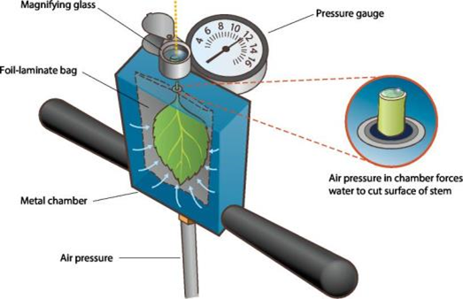
Figure 1. Schematic showing how water potential is measured in a severed leaf and stem (petiole) using a hand-held pump-up pressure chamber. Source: Adapted from Plant Moisture Stress (PMS) Instrument Company.
_______________________________________________________________________________
Tracking Winter Irrigation Needs
Concerns of irrigating during a dry autumn were quenched along with the Camp Fire in late November when heavy rains came to the Sacramento Valley. Weather forecasts give an 80% chance of a weak El Niño during winter 2018-2019, that may bring above average rainfall (climate.gov/enso). Although the need to irrigate to replenish soil moisture has been abated for the time being and the forecast is promising, it is wise to continue tracking rainfall levels and the resulting soil moisture profile in your orchards. By tracking rainfall, it is possible to substitute irrigation for the shortage in rainfall on a monthly basis beginning in December until enough rainfall in combination with irrigation has been received to refill the soil profile at least three feet deep.
See winter rainfall tracking at: http://www.sacvalleyorchards.com/blog/thinking-about-irrigating-this-winter/
_______________________________________________________________________________

The Rot from Within: Wood Decay in Almond
Luke Milliron, UCCE Farm Advisor for Butte, Tehama, and Glenn Counties
Bob Johnson, PhD Candidate Rizzo Lab, UC Davis Plant Pathology

In March of 1995 a four-day storm with winds reaching nearly 65 mph and a deluge of six-inches resulted in an estimated 15,000 acres of downed almond trees in California, with losses at the time calculated at $210 million. Joseph Connell (UCCE Butte) and Dr. Jim Adaskaveg (Plant Pathology, UC Riverside) surveyed downed trees and categorized the potential predisposing factors. Part of the study’s findings were that white rot fungi may have played a role in tree loss. They observed basidiocarps (fruiting bodies) of Oxyporus spp., Phellinus gilvus, Ganoderma brownii, and Gloeoporus dichorus associated with a portion of the downed trees. This study was key to the understanding that wood-decay fungi can contribute to serious tree losses during winter storm events.

Twenty years later, Bob Johnson, a graduate student in the department of Plant Pathology at UC Davis, began research into wood-decay fungi in almonds. In 2015 he set out to survey California’s almond growing regions and identify the main wood-decay fungi associated with windfall. Ganoderma species were identified as the primary cause of decay in windfall trees, specifically G. brownii and G. adspersum. These decay fungi cause internal decay from the butt, or base of the trunk (near soil level) and invade upwards, often remaining completely undetected before the windfall event.

Wood-decay infections by part of the tree: roots, butt and roots, and scaffold:

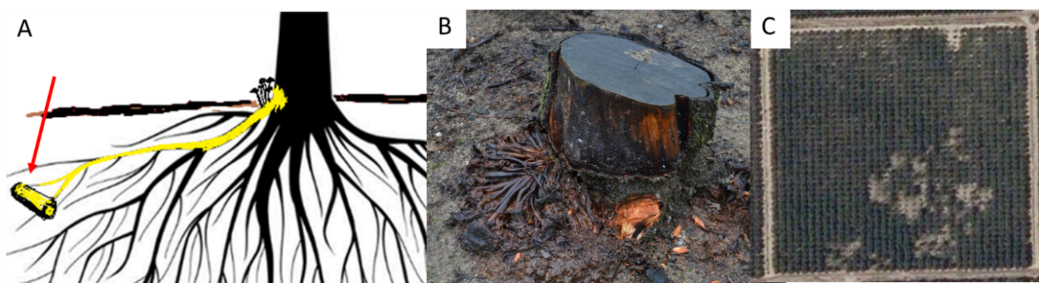
Figure 1. Roots: Armillaria root rot (oak root fungus) is a primary pathogen and a wood-decay disease. This disease, well-known by many almond growers, can occur when there is close contact between diseased and healthy roots, without any wounding necessary (A). Killed trees remain standing until they are cut down (B), with disease typically occurring in specific patches in the orchard (C). For more information see: www2.ipm.ucanr.edu/agriculture/almond/Armillaria-Root-Rot-Oak-Root-Fungus/

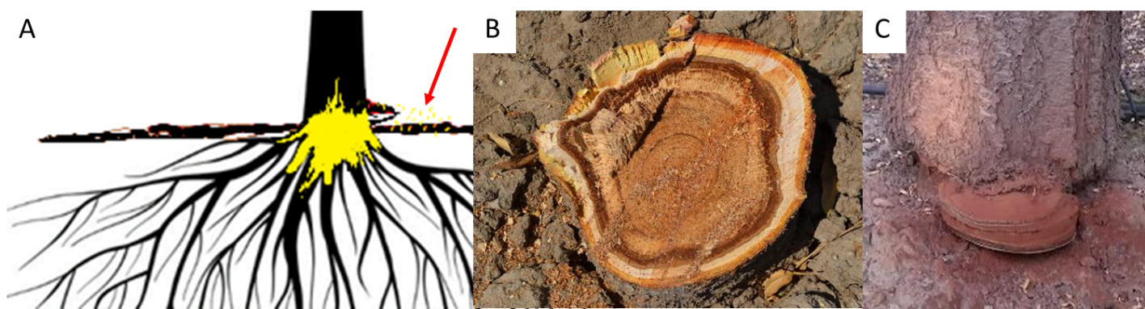
Figure 2. Butt and roots: Ganoderma spp. infections, begin with spores infecting through a wound, at or below the soil surface (A, see arrow). The disease decays the butt of the tree and the tree is killed at windfall (B). The only external sign of the disease is conk fruiting bodies at the base of the tree that appear after extensive rot has already taken place. These disperse airborne spores (A, C).

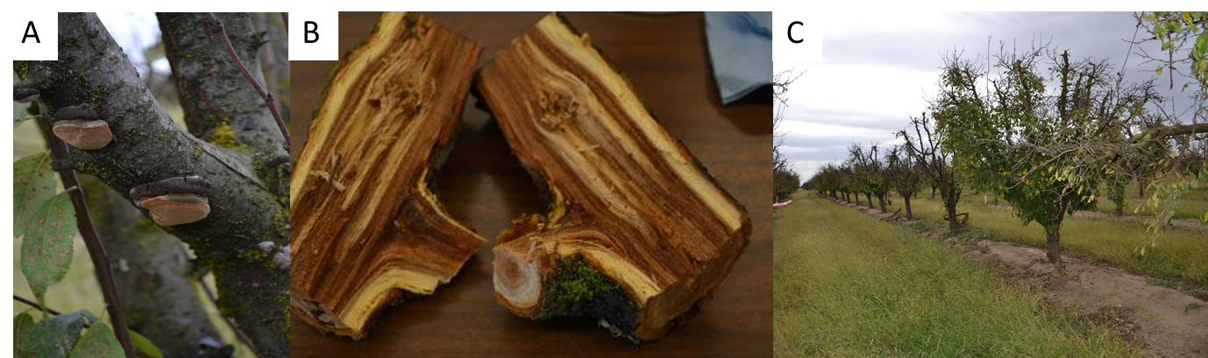
Figure 3. Scaffold: The heart rot of Phellinus tuberculosus, which infects through pruning wounds, is major disease in prune production (A-C). Although Phellinus spp. can infect almond, it is not widely observed, perhaps because there is less pruning performed than in prune production. Much like Ganoderma spp. infections, conks are the only sign visible on the exterior (A). In prune production, heart rot infections often break scaffolds during the shaking process at harvest.

Ganoderma butt rot: Young orchards prevalent in new survey’s windfall losses:
As Johnson communicated with growers about his efforts, he began receiving reports of windfall trees to investigate. Most disturbingly, many of the calls concerning windfall were reporting losses in young, otherwise healthy trees. Previously the consensus was that wood- decay fungi were non-aggressive and were secondary pathogens most often associated with older orchards. For example, in the 1995 survey, Lovell rooted almond orchards had windfall loses between 6.2% and 20% for four orchards ranging in age from 15-21, versus 3.3% loss in the youngest (8th leaf) orchard. Reports of windfalls of trees in older orchards have continued, and in these cases G. brownii, one of the species from the 1995 survey, is often the problem. However, Johnson has also received reports of extensive windfall losses in orchards as young as seven years old. In these cases he has identified G. adspersum, which had not been previously been reported in California. These losses have been so severe in several cases that orchards as young as 10 years old have been completely removed following the extensive losses. Thankfully for Sacramento Valley growers, all of the orchards with G. adspersum infections have been identified in the middle to southern San Joaquin Valley.
Why the more aggressive G. adspersum has not been discovered in the Sacramento and Northern San Joaquin Valley is a mystery. Perhaps more fungal diversity and competition of both pathogenic and benign fungi in our historical orchard growing region has prevented widespread G. adspersum infections. But most likely, this species, which is native to Europe, has not yet made its way north to the Northern San Joaquin and Sacramento valleys.
Researching how infections occur and how they can be managed:
The latest wood rot research has focused on how the infections are taking place, and what management tools are available. The current theory for these fungal infections is that trees are predisposed to infection through wounds at or below the soil line, inflicted during harvest or winter sanitation shaking. Windborne spores are then dispersed during sweeping and pickup harvest operation with subsequent irrigation allowing spores to percolate into the soil and germinate. Since this route of infection is unavoidable in current almond production, Johnson has focused on testing rootstock susceptibility and efficacy of commercially available biological materials (i.e. Trichoderma spp.) that may out compete the wood-decay fungi. Theoretically removing the conks (fruiting bodies of wood-decay fungi) may also help, especially if those conks, which can sporulate year-round, happen to be active during harvest operations.
Sacramento Valley growers have so far been spared from the most aggressive wood-decay induced windfall losses. However, this may not always be the case. Growers should carefully evaluate tree losses due to windfall, particularly in younger orchards, for the presence of internal rotten wood at the butt or site of branch breakage. If you suspect wood-decay fungi led to windfall losses in your young almond orchard, please contact your local UC Cooperative Extension farm advisor.

Growing the Valley Podcast: Almond episodes posted!
Listen to the UC Cooperative Extension podcast hosted by Butte County Farm Advisor Luke Milliron and Madera County Farm Advisor Phoebe Gordon!
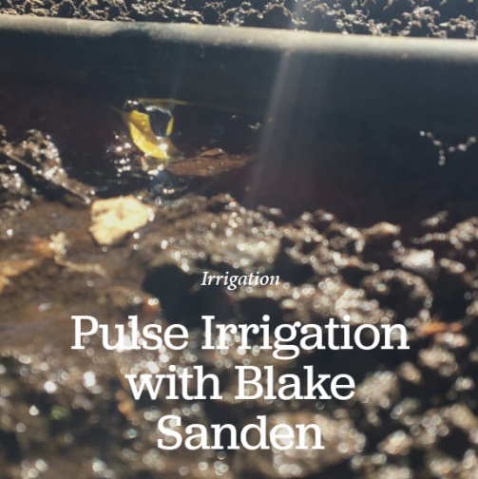
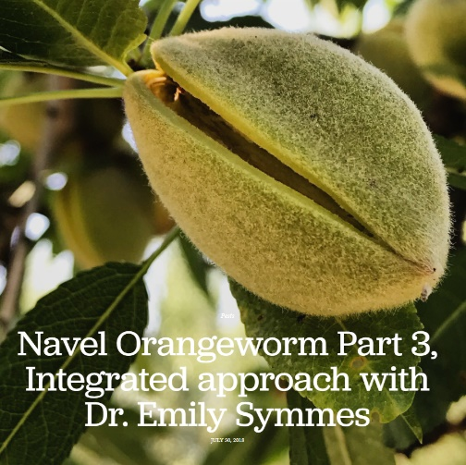
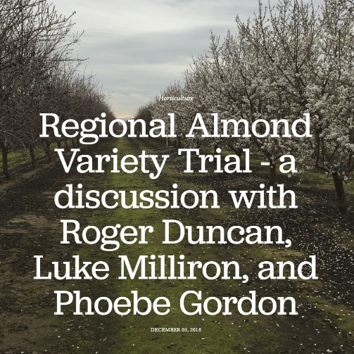

Listen and learn more at: https://www.growingthevalleypodcast.com/ Subscribe at Apple iTunes and Google Play Music

Protecting Honey Bees at Bloom
Emily J. Symmes, Area Integrated Pest Management Advisor,
Sacramento Valley & University of California Cooperative Extension and Statewide IPM Program

It’s time for your annual pollinator safety reminder! Everyone should know to avoid insecticides when honey bee colonies are in the orchard. The only insect pest that could potentially be considered for treatment when honey bees are in the orchard is peach twig borer (PTB). Applications of Bacillus thuringiensis (Bt) during this time have been shown to be non-toxic to honey bees. This material is the only viable option to manage PTB at this time, while protecting the pollinators you pay so dearly for. There are also alternative and equally effective timing(s) for managing PTB under different circumstances. More detail on PTB management using Bt and alternative treatment timings is available at: http://ipm.ucanr.edu/PMG/r3300211.html.
Ongoing research continues to examine the impacts of fungicides and adjuvants on acute adult bee toxicity (how damaging sprays are to actively foraging adults), and also the effects on the developing brood that are fed pesticide-contaminated pollen. As you can imagine, there are a huge number of potential combinations of fungicides, adjuvants, and tank mixes that bees may be exposed to in the orchard during bloom.
Below are some take-home messages for bloom fungicide applications and links to resources:
Fungicides – how many sprays are needed?
- Conditions will dictate the number of bloom sprays needed for disease management. If the weather is dry and clear throughout bloom, there will be minimal need to apply fungicides during this period. Under environmental conditions not conducive to disease development, UC researchers (Adaskaveg et al. 2017 – link below) suggest minimizing the total number of fungicide applications during bloom by making a single delayed bloom application at 20 to 30% bloom.
- Under wet bloom conditions, multiple bloom fungicide applications may be warranted. Practice sound integrated pest management practices – treat only for those pathogens that are best controlled during bloom (see table below) and those you know are a potential threat in your particular orchard or block based on monitoring or history. The online UC IPM guidelines (http://ipm.ucanr.edu/PMG/selectnewpest.almonds.html) provide details on monitoring and treatment timings for key almond diseases.
- Adjuvants – are they needed?
- According to the authors of the annual Fungicides, Bactericides, And Biologicals for Deciduous Tree Fruit, Nut, Strawberry, And Vine Crops (Adaskavag, Gubler, and Michailides 2017, http://www.ipm.ucanr.edu/PDF/PMG/fungicideefficacytiming.pdf), “most fungicides are formulated with adjuvants including wetting agents, spreaders, and stickers. Unless a material specifically indicates on the product label that an adjuvant should be added, the fungicide product does not need additional adjuvants mixed into the sprayer tank to improve performance. With few exceptions, adjuvants do not statistically improve the efficacy of fungicides for managing diseases of fruit and nut commodities.”
- All University of California efficacy trial results (+++’s in the efficacy table) are based on this premise and materials are tested without addition of adjuvants unless expressly indicated on the product label.
- Adjuvants may increase the potential toxicity of fungicides to honey bees. To save money and protect bees, only put what is absolutely necessary in the tank.
Choosing materials:
- Know the impacts of particular fungicides on honey bees and choose materials accordingly.
- Visit the University of California IPM Program’s “Bee Precaution Pesticide Ratings” at https://www2.ipm.ucanr.edu/beeprecaution/
- Use this database to find precaution ratings for any material you are considering applying during bloom (searchable both by common name and trade name).
- These precaution rankings (I, II, III) have been created based on all of the currently available scientific studies, including adult bee toxicity and effects on bee brood. As there are many materials and tank mix combinations yet to be examined, use the information contained here conservatively and always proceed with caution (err on the side of bee safety).
“Bee-safe” applications:
- Apply fungicides when available pollen is at the lowest possible levels (late afternoon through very early the following morning). Pollen is released in the mornings when temperatures reach 55º F, and is often removed by foraging honey bees by mid-afternoon. The “bee-safest” time to apply fungicides is in the evening or at night when temperatures are less than 55º F.
- Never spray hives or bees directly with any material. Contaminated foraging worker bees will carry the fungicide back to the hive where other worker bees will clean them and contaminate the hive’s food supply. Aside from these toxicity concerns, bee flight ability can be impacted from the weight of any spray droplets (even water – which is why they don’t effectively pollinate during inclement weather) and any water, from sprays or rain, can cause pollen grains to burst affecting pollination.
The Almond Board of California pollinator resource pages (http://www.almonds.com/pollination) provide additional information and links to best management practices for protecting honey bees during almond bloom.

Almond Bloom Diseases
Dani Lightle, UCCE Farm Advisor, Glenn, Butte, & Tehama Cos.
Franz Niederholzer, UCCE Farm Advisor, Colusa and Sutter/Yuba Counties

Almond bloom is quickly approaching. Diseases require specific conditions for infection – susceptible tissue, moisture, conducive temperatures – and these are often all present during bloom. Appropriate material choice, application timings and coverage are critical to minimize losses. Below are susceptibility and treatment information for the primary spring diseases in almond production.
Brown Rot (Monolinia laxa or M. fructicola)
- Most susceptible cultivars: Butte, Carmel, Winters, Wood Colony.
- Infection timing: Pink bud through petal fall; highly susceptible when flowers are open.
- Favorable conditions for infection: Rainy weather (or high humidity/dew) and warm temperatures (over 58oF).
- Treatment timing: If it’s a dry (no rain) spring, one application at 20-40% bloom. If infections were severe last year, or it is a wet spring, treat at pink bud (5% bloom) and full (80%) bloom.
Anthracnose (Colletotrichum acutatum)
- Most susceptible cultivars: Butte, Fritz, Monterey, Peerless, Price, Winters. Nonpareil is less susceptible than others. All cultivars are susceptible.
- Infection timing: Pink bud through May if rain continues.
- Favorable conditions for infection: Warm, rainy weather. Wet tissue and temperatures over 59oF carry the greatest risk for anthracnose infection.
- Treatment timing: Apply beginning at pink bud (5% bloom) and repeat every 10-14 days if rain continues (possibly into May, if late spring rains occur).
- Material considerations: Rotate fungicide FRAC groups to delay resistance development. See the fungicide efficacy table (separate insert) for effective materials.
Green Fruit Rot (Botrytis cinerea, Sclerotinia sclerotiorum, and Monilinia laxa)
- Infection timing: Latter part of full bloom to petal fall when senescing petals and anthers are present
- Favorable conditions for infection: Cool, rainy weather, and nut clusters that trap senescing flower parts.
- Treatment timing: Full bloom, when bloom is extended and weather is cool and wet.
- Material considerations: DMI fungicides (FRAC 3) are ineffective against Botrytis.

Bacterial Blast (Pseudomonas syringae)
- Most susceptible cultivars: Ne Plus Ultra, Peerless. Plum rooted trees are more susceptible than those on peach rootstock.
- Infection timing: Swollen bud through the small nut stage.
- Favorable conditions for infection: Cold, wet, and/or frosty weather.
- Treatment timing: None recommended at this time. A dormant copper treatment is sometimes suggested, but efficacy studies have not demonstrated control with a copper program. Where copper is used regularly Pseudomonas has been confirmed to be copper resistant.
Shot hole (Wilsonomyces carpophilus)
- Most susceptible cultivars: Butte, Carmel, Fritz, Price, Sonora
- Infection timing: Bloom through spring. Prolonged, wet spring weather results in the greatest risk of damaging levels of this disease, which can drop nuts and defoliate trees.
- Favorable conditions for infection: High levels of inoculum and wet weather. Monitor for fruiting bodies (sporadochia) in leaf lesions in spring.
- Treatment timing: If fruiting bodies were found on leaves the previous fall, spray at petal fall or when new leaves emerge. If no fruiting bodies seen the previous fall, wait to spray until fruiting bodies are found on current season leaves. Once present, apply protective fungicides prior to additional rain.
Bacterial spot (Xanthomonas arboricola pv. pruni)
- Most susceptible cultivars: Fritz (highly susceptible), Butte, Carmel, Nonpareil, Price
- Infection timing: Infections occur in the spring but a delayed dormant and a bloom spray can deliver good to excellent control of this spring disease.
- Favorable conditions for infection: wet and warm (>68oF) conditions
- Treatment timing: Dormant or delayed dormant (copper + mancozeb) reduced infections by more than 75% in UC research. Single applications of copper or copper + mancozeb at full bloom or petal fall provided excellent disease control in the same studies.
Reminders for best control:
- Spray every row after pink bud. Every-other-row spraying = every-other-row control.
- Follow the RULES for resistance management:
  - Rotate fungicide chemistries
  - Use labeled rates
  - Limit the use of a single site fungicide to once or twice a year
  - Educate yourself on fungicides and their modes of action. Free info at: http://www.ipm.ucanr.edu/PDF/PMG/fungicideefficacytiming.pdf and in this newsletter.
  - Start strong: begin your fungicide program with a multi-site fungicide or mixture of different single site materials to reduce the pathogen populations and resistance risk to any single site fungicide used later in the season.

Please Participate - Grower Perspectives on Soil Management in Almonds
What are the challenges you have with managing soil quality? What practices do you use or would you like to try out? Researchers at UC Berkeley are doing a project on the practices almond growers are using to improve soil quality. We hope to use the information gathered to help create California policies that will benefit growers and their soils.
Please participate in our project to understand grower challenges and opportunities related to managing soil quality in almonds. If you are available for a brief interview, please email Joanna Ory at joannaory1@berkeley.edu or call (650) 937 – 9567. Thank you very much for your time!

2019 IPM Breakfast Meetings
Join Area IPM and Farm Advisors to discuss current pest management and production issues. We will largely focus on orchard crops (but everything is on the table for discussion!). These meetings are open to all interested growers, consultants, PCAs, CCAs, and related industry.
Meetings will be held the second Friday of each month (8:00-9:30am *note new start time*) from March through October and will cover a wide range of timely pest and orchard management topics. Meeting locations will be rotated throughout the Sacramento Valley each month. Please contact Emily Symmes to request topics or bring your questions to the meeting!
2019 meeting dates:
- March 8th, 2019 (Butte County): Red Rooster Café, Durham
- April 12th, 2019 (Yuba-Sutter-Colusa Counties): Location TBA
- May 10th, 2019 (Tehama County): Field Meeting, Location TBA
- June 14th, 2019 (Glenn County): Field Meeting, Location TBA
- July 12th, 2019 (Butte County): Field Meeting, Location TBA
- August 9th, 2019 (Yuba-Sutter-Colusa Counties): Field Meeting, Location TBA
- September 13th, 2019 (Tehama County): Rockin’ R Restaurant, Red Bluff
- October 11th, 2019 (Glenn County): Berry Patch Restaurant, Orland

Additional details will be posted on the events page at sacvalleyorchards.com
RSVPs required at (530) 538-7201 or ejsymmes@ucanr.edu
**DPR and CCA Continuing Education hours requested**

Industry Partners: Sponsorships for venue and refreshment costs are welcome and appreciated. If you would like to sponsor one or more of these meetings, please contact Emily Symmes to inquire.

ANR NONDISCRIMINATION AND AFFIRMATIVE ACTION POLICY STATEMENT FOR UNIVERSITY OF CALIFORNIA May, 2015. It is the policy of the University of California (UC) and the UC Division of Agriculture & Natural Resources not to engage in discrimination against or harassment of any person in any of its programs or activities (Complete nondiscrimination policy statement can be found at http://ucanr.edu/sites/anrstaff/files/215244.pdf. Inquiries regarding ANR’s nondiscrimination policies may be directed to John I. Sims, Affirmative Action Compliance Officer/Title IX Officer, University of California, Agriculture and Natural Resources, 2801 Second Street, Davis, CA 95618, (530) 750-1397.

