In This Issue

- Nickels Soil Lab Annual Field Day

- Naval Orangeworm in 2015

- Almond Scab

- Band Canker

- N Budgeting Following the 4 R’s

- In-Season Almond Orchard Management Considerations

Franz Niederholzer
UCCE Farm Advisor
Sutter, Yuba, Colusa Counties

Navel Orangeworm in 2015
Emily J. Symmes, UCCE Area IPM Advisor, Sacramento Valley

NOW management in the Sacramento Valley relies heavily on sanitation, early and rapid harvest, and hull split treatments when necessary to protect the new crop. Proper execution of these practices keeps NOW populations below damaging levels. This year we may face higher navel orangeworm pressure due to the dry winter that made sanitation more difficult while reducing natural overwintering mortality.

Warm spring temperatures led to earlier NOW egg biofix dates this year which will lead to earlier third generation egg laying as harvest approaches and the likelihood of a fourth generation before harvest is complete. May sprays, under discussion in other parts of the state, reduce NOW and PTB populations if timed properly but do not protect the maturing crop.

While May sprays targeting first generation NOW might seem like an attractive option if high populations going into hull split are anticipated, there are limitations to this strategy in the northern parts of the Central Valley. May sprays will reduce resident populations but will not protect the new crop when it becomes vulnerable to NOW infestation at hull split from resident or immigrant moths. May sprays may help in the southern Central Valley, where almond blocks tend to be much larger, resident NOW populations higher due to very low sanitation thresholds, and regional pressure greater due to proximity to other sources of infestation (i.e., pistachio orchards), but aren’t generally a great fit for the Sacramento Valley.

Applying May sprays for peach twig borer (PTB) and obtaining simultaneous control of NOW is also appealing. However, this is not a guarantee and will only occur if the life cycles of the two pests are synchronized and/or the material chosen has long residual impacts. Therefore, PTB should be treated only as necessary based on monitoring and threshold values (see http://www.ipm.ucdavis.edu/PMG/r3300211.html for information on PTB management). In addition, application of certain materials during spring disrupt natural enemies of webspinning spider mites and increase the need for miticide treatment. Given these considerations in the Sacramento Valley, hull split treatments provide maximum crop protection from NOW with minimal non-target and secondary pest impacts.
Proper timing of hull split treatments involves monitoring egg traps, using degree days, and crop phenology. If you choose to treat at hull split,
If eggs are being laid on egg traps, time the spray to the initiation of hull split.
If eggs are not being laid on egg traps when hull split begins, time the spray to an increase in egg-laying on traps or the predicted initiation of egg-laying according to degree day models, 1200 degree days after spring biofix.
Hull split initiation is when sound fruit in the tops of trees begin to split. At this time, the nuts at eye level will be less mature and will show only a deep furrow at the hull suture. Nuts in the top southwest quadrant of the tree split first. Blank nuts (usually 3 to 5%) will split 1 to 2 weeks ahead of sound nuts. Use a long-extension pole pruner to cut small branches from this top portion of five or six trees in the orchard to check whether hull split nuts are blank or sound.

Almond Scab
Joseph Connell, UCCE Farm Advisor Emeritus, Butte County

The scab fungus, Cladosporium carpophilum, begins its seasonal cycle by producing spores on the previous year’s twig lesions. These spores can be moved to uninfected tissue and trigger disease outbreaks when subsequent rains occur. Watch for sporulation (black ring on the edge of old lesions; Fig.1) now and once spores are present, be prepared to provide protection if rain is forecast.

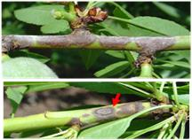
Figure1. Twig lesions without spores (top) and with spores present (bottom).

If rain occurs after twig lesions sporulate, an epidemic scab outbreak can be present by June. Scab infections occur on both leaves and hulls ultimately producing oily greyish black spots on both (Fig.2). Severe infections cause premature defoliation, weakening trees and potentially reducing yield. This disease is favored by protracted spring rains.

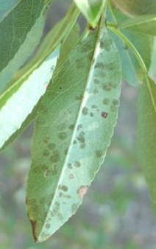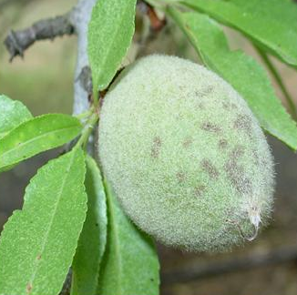
Figure 2. Scab lesions on leaves (left) and on hulls (right).

Spring sprays in April focus on protecting the leaves, fruit, and young twig tissues from new infections but don’t affect spore formation on existing twig lesions. Sprays at five weeks after petal fall will control scab if additional rain is expected. Later sprays have provided additional control in wet springs.

Recent research on scab has shown that a late January delayed dormant application of copper or Bravo® plus oil is an effective treatment that delays spore production on overwintering twig lesions for at least a month. Since spores are often produced in mid-April, delaying sporulation until mid to late May is often late enough to miss spring rains thus avoiding a scab outbreak.

Photos courtesy of Dr. Jim Adaskaveg, Plant Pathology, UC Riverside. See the UCIPM website, http://www.ipm.ucdavis.edu/PDF/PMG/fungicideefficacytiming.pdf for more information.

Band Canker
Joseph Connell, UCCE Farm Advisor Emeritus, Butte County

Band canker, caused by Botryosphaeria dothidea and other Botryosphaeria spp., has historically been a relatively rare problem in almond orchards, primarily affecting trees from their third through sixth growing seasons. It’s believed cankers begin in the spring or the fall when temperatures and rain or sprinkler water create favorable conditions for infection. Trunks and lower limbs are infected through growth cracks in the bark (Fig.1).

During the growing season amber-colored gum exudes from the cankered area forming a band of gumballs around the affected part of the tree. Many varieties are susceptible but cankers are most commonly found on the most vigorous variety in affected orchards, frequently Nonpareil or Padre. Although they can be chronic, cankers often don’t reactivate the following year. If not girdled, the tree may recover.
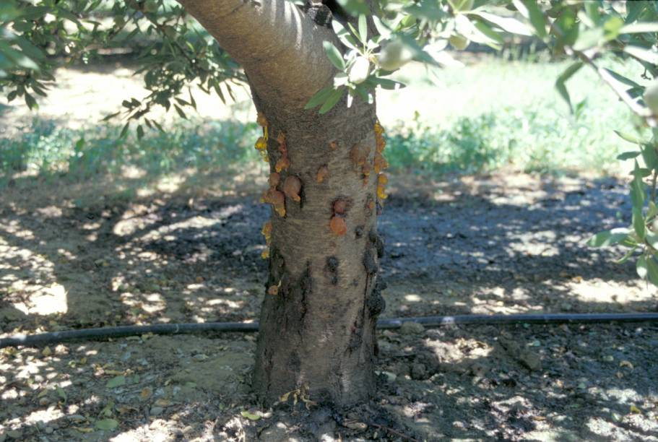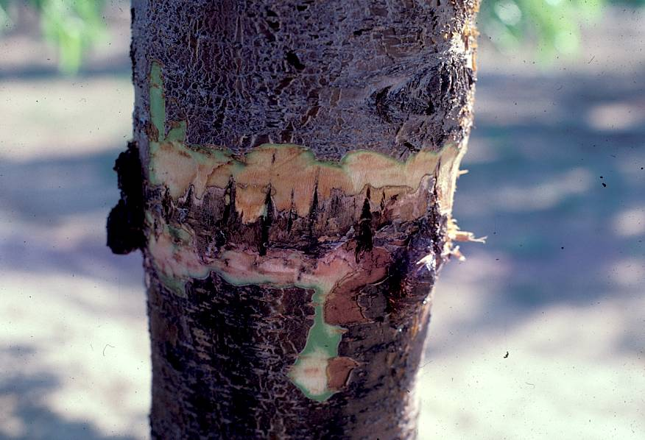
Figure 1. Current season and a previous seasons gumballs on an almond trunk (left). Growth cracks infected by a Botryosphaeria fungus (right). Photos courtesy of Dr. Themis Michailides, Plant Pathology, UC Davis, Kearney Agricultural Center.

Although less common, Botryosphaeria has also been found to infect almond through pruning wounds, lenticels, cracks at the base of shoots, growth cracks on branches, and through nut peduncles. The fungus has both water-splashed spores and airborne windblown spores. I’ve seen young almond orchards affected by band canker that were downwind during storms from older walnut orchards containing Botryosphaeria infected dead wood. Botryosphaeria is now a significant concern in walnut orchards with management of the disease in that crop currently under study.
Botryosphaeria has a wide host range including blackberries, almond, walnut, pistachio, and other tree species. The fungus produces airborne spores on infected dead wood, so a good sanitation program to promptly remove dead wood and stumps of trees killed by Botryosphaeria can reduce disease pressure in almond orchards. Other management practices include using splitters (deflectors) on irrigation sprinklers to prevent irrigation water from hitting tree trunks or scaffolds, and, removal of alternate infected hosts adjacent to young almond orchards.

N Budgeting Following the 4 R’s
Katherine Pope, UCCE Orchard Advisor Yolo, Solano, & Sacramento Cos.
Bruce Houdesheldt, Sacramento Valley Water Quality Coalition

Nitrogen management, for farm planning or regulatory compliance, boils down to one fundamental concept – matching supply with demand. When supply is greater than demand, nitrogen (N) can be lost from the root zone and leached into groundwater aquifers. Matching supply with demand relies on the 4 R’s of nitrogen management – applying nitrogen at the Right Rate, at the Right Time, in the Right Place and using the Right Source. When timing or amount of supply doesn’t match demand, yield can be reduced compared to yield under properly fertilized conditions.

Right Rate. UC research led by Professor Patrick Brown found around 68 lbs N for every 1,000 pounds of almond kernel yield covers the nitrogen needs of an almond orchards crop, plus N in the hulls, leaves and other scraps. This number has a fudge factor to cover vegetative growth for yields over 2,000 lbs per acre.
Right Time. To match delivery with tree N use, Dr. Brown’s group recommends applying N four times during the season at different amounts – 20% of annual N input in February - March, 30% in April, 30% in June and 20% in September – October (as soon as possible after harvest).
Right Place. For the trees to take up N, it needs to stay in the root zone. Most almond roots are in the top 2-3 feet of the soil. Managing irrigation to decrease leaching also keeps nitrogen where the tree can use it.
Right Source. In Dr. Brown’s experiment, there was no difference in yield between equal annual amounts of N as UAN 32 or CAN17. Material choice is more a function of price per unit N, and other needs particular to your orchard, like pH impact.

ESTIMATING DEMAND
The 4 R’s of nitrogen management combine to estimate crop demand. To figure out how much N your trees needs in any given year, combine (a) estimated yields with (b) N removed in the crop and (c) your estimated nitrogen use efficiency.
a) To get estimated yields, a good approach is averaging your last 5 years of yield, then decreasing or increasing that number based on considerations like conditions during bloom, a very heavy or light crop last year, etc.

b) As discussed above, 1000 lb kernel crop of almonds (kernels plus shells and hulls) contains 68 lbs N (0.068 lb N for every 1 lb kernel). An orchard that produces 2500 lbs kernel crop/acre will remove 170 lbs N/acre from the orchard in the crop.

c) Your nitrogen use efficiency (NUE) – how much N is taken up by the trees per lb of fertilizer N applied - depends on how closely you follow the 4 Rs. If you are budgeting 68 lbs N per 1,000 lbs kernel crop, dividing your fertilizer N applications into the four recommended applications (20%-30%-30%-20%) and irrigating to match ETc, you should achieve NUE levels of around 70%. To use the percent NUE in calculations, convert percent to decimal by dividing by 100.

The three components above can be combined to produce a recommended nitrogen application for a block, using the following equation:

N Demand (lbs/ac) = _[Est. Yield]_ (lbs/ac) x 0.068 (lbs N / 1 lb kernel) ÷ _[NUE Factor]__
Example: A 2500 lb kernel/acre crop contains 170 lbs N/acre. If N is delivered into the tree with 70% efficiency, then the grower should apply 243 lbs fertilizer N to meet crop N demand – assuming no other N source(s).

ESTIMATING SUPPLY
In addition to synthetic fertilizers (urea, UN32, CAN-17, etc.) there are other potential suppliers of N, such as manure, compost and irrigation water. To figure out how much synthetic fertilizer may be necessary for your expected crop, subtract the non-synthetic supply from the estimated demand.

- Exactly how much nitrogen in manure/compost is available to plants and when it’s available is complex and continues to be researched. Each soil type and climate responds differently to these amendments, so use your own experience and judgment when putting the following numbers to use. If you don’t use manure or compost often, only some of its N will be available the year it’s applied - 5-10% for cured compost, 15-30% for dried or aged manure (poultry or bovine).* If you apply about the same amount of the same N content manure or compost annually, it should reach a steady state of turn-over, where N in this year’s application roughly equals N released from previous applications. Convert percent to decimals for calculations below. Always use dry weight of manure/compost and %N on dry weight basis.
N in Manure/Compost =
Apply every year _[Dry lbs manure/compost per acre]_ x _[% N]_
Apply just this year _[Dry lbs manure/compost per acre]_ x _[% N]_ x _[% Available]_

- Estimating N in irrigation water requires a nitrate lab test. The result then must be converted into pounds N in an acre-inch of water, and multiplied by the acre-inches of irrigation water applied (or expected to be applied). Results may come back from the lab as NO₃N-N or NO₃. These two types of reporting (NO₃N-N or NO₃) use different conversion factors to get to N/acre-inch*.
N in Irrigation Water (lbs/ac) =
NO₃N-N [NO₃N-N]_ (ppm or mg/l) x 0.225 x _[Acre-inches of Irrigation]_
NO₃ _[NO₃]_ (ppm or mg/l) x 0.051 x _[Acre-inches of Irrigation]_

The Nitrogen Management Plan template from the Sacramento Valley Water Quality Coalition calls for many of the numbers calculated above. If you did not receive a template, need help filling it out or have other questions about implementation of the Irrigated Lands nitrogen plans, contact Bruce Houdesheldt at the Sacramento Valley Water Quality Coalition: bruceh@norcalwater.org or (916) 442-8333. The water coalitions are still hammering out official numbers for filling out these forms. The numbers given above are a starting point. Official numbers from the Coalitions should be established by late this fall.

For more on the 4 R’s, see the article “Nitrogen use efficiency in almonds” at http://cetehama.ucanr.edu/Newsletters_510/?newsitem=53482

*Based on numbers from UC ANR publication #21623, Guide to Efficient Nitrogen Fertilizer Use in Walnut Orchards (2006) by K. Kelley Anderson, J. Grant, S. Weinbaum & S. Pettygrove.

In-Season Almond Orchard Management Considerations
Luke Milliron, UCCE Horticulture Intern, Yuba, Sutter and San Joaquin Counties.

Water Management:
- Short on water this season? UC researchers found hull split deficit irrigation can save up to 15% of normal crop water use. Depending on soil water holding capacity, irrigation system, etc., deficit irrigation can start as early as June. If water supply reduction is greater than 15%, irrigation should be evenly reduced as a percentage of ETc over the season. Further details:
anrcatalog.ucdavis.edu/pdf/8515.pdf

Nutrition Management:
- Take leaf samples in mid-July to monitor the progress of your fertilizer program and ensure that excessive nitrogen does not predispose your trees to hull rot. See “Leaf analysis and salinity monitoring” in cetehama.ucanr.edu/newsletters/Fruit_-_Nut_Newsletters52045.pdf for more information.

Insect Management:
- Monitor navel orange worm (NOW) egg traps in April (see article in this newsletter) to establish the biofix for hull split flight. Trapping form and degree-day model: ipm.ucdavis.edu/PMG/C003/m003bceggtrapsnvl.html
- Monitor for peach twig borer (PTB) shoot strikes beginning mid-April. If there are four or more shoot strikes per tree on mature trees, control may be warranted with a May spray application, timed using trap catches and degree-days.
Monitoring and control information: ipm.ucdavis.edu/PMG/r3300211.html
- San Jose scale (SJS) feed on nutrients from limbs and spurs and inject toxins that can kill fruiting wood. The pest is not usually significant when broad-spectrum sprays have not disrupted parasitoid activity. Monitor in season with pheromone traps to detect male scales and parasitoid activity. Monitoring and control information at: ipm.ucdavis.edu/PMG/r3300811.html
- Monitor ant mounds in May and June to determine if the number of southern fire ant or pavement ant mounds warrants a bait application before harvest.
Monitoring and bait application information at: ipm.ucdavis.edu/PMG/r3300411.html
- Starting in May, monitor weekly for spider mites and their predators, paying particular attention to water stressed areas of the orchard and other previous hot spots. Use UC IPM thresholds to determine if a miticide is necessary. Monitoring and control information at: ipm.ucdavis.edu/PMG/r3400211.html

Disease Management:
- If we have mid-to late spring rain events, consider almond scab protection measures (see article in this newsletter). More information: ipm.ucdavis.edu/PMG/r3100411.html
- If rust was present last year, monitor leaves in young orchards and on replants for lesions from April to June. If rust is present, spray to prevent premature defoliation. Control guidelines can be found at: ipm.ucdavis.edu/PMG/r3100711.html
- Anthracnose can infect nuts and spurs until spring rains end, which may require fungicide applications as late as May. Sanitation, cultural control, and fungicide rotation information can be found at ipm.ucdavis.edu/PMG/r3101111.html
- Monitor for Alternaria (leaf spot) from May to June, looking for 0.5 to 0.75 inch brown spots that become black when spores are produced. If the disease is present in mid-April follow the treatment recommendations at: ipm.ucdavis.edu/PMG/r3101611.html

Weed Management:
- Conduct a weed survey in May to evaluate changing weed populations, effectiveness of herbicides and the development of resistance. The weed survey form and weed identification links at: ipm.ucdavis.edu/PMG/C003/m003bcweeds01.html

ANR NONDISCRIMINATION AND AFFIRMATIVE ACTION POLICY STATEMENT FOR UNIVERSITY OF CALIFORNIA SINGLE PAGE FLYERS FOR EDUCATIONAL PROGRAMS ONLY July, 2013 It is the policy of the University of California (UC) and the UC Division of Agriculture & Natural Resources not to engage in discrimination against or harassment of any person in any of its programs or activities (Complete nondiscrimination policy statement can be found at http://ucanr.edu/sites/anrstaff/files/169224.pdf ) Inquiries regarding ANR’s equal employment opportunity policies may be directed to Linda Marie Manton, Affirmative Action Contact, University of California, Davis, Agriculture and Natural Resources, One Shields Avenue, Davis, CA 95616, (530) 752-0495.

