Practices to consider in prune orchards this fall.
In This Issue

- Practices to consider in pune orchards this fall

- Scale Pests in Prune Orchards and Keeping a Balance of natural Enemies to Control Them

- Prune out Cytospora cankers to reduce disease

- Fall Spray for Prune Aphid Management

- Using high oil rate before bloom: Why do it?

- Short, timely prune updates available

Submitted by:

Franz Niederholzer,
UC Farm Advisor
UCCE Sutter-Yuba Counties

- Irrigation: There are lots of leaves on many prune trees this fall. If it continues to be a warm fall and rain is not in the forecast, consider irrigating a second time once soil or tree moisture monitoring shows the orchard needs water. Cytospora cankers run faster in water stressed trees, and there is some evidence that prune trees receiving no fall irrigation produce smaller buds.

- Dormant Spray Options: See articles in this newsletter.

- Prune Aphid: See article in this newsletter.

- Orchard Fertility: Plan your fall fertilizer program.

    - Potassium: Fall is the best time for soil applied potassium fertilizer in flood or solid-set irrigated blocks. Band or shank potassium sulfate on/in the soil under the canopy at a maintenance rate of 400-500 pounds of material per acre. Potassium chloride (muriate of potash) works as well. Usually 300-400 pounds/acre of that material is all that is needed. Wait until trees are dormant before using potassium chloride. Potassium chloride is less expensive, but chloride can burn roots and damage the tree if it is not leached from the root zone before spring. Ten inches of water – rain or irrigation – is needed to “flush” chloride out of the root zone. Root growth begins about 6 weeks before bloom.

    - Nitrogen: If you want to apply N in the fall, know that trees will use no more than 20 pounds of N/acre at this time of the year. Once leaf drop has started, soil nutrient uptake – especially N – is finished for the season. Dormant trees absorb almost no N.

    - Zinc: 20 pounds/acre of 36% zinc sulfate is an effective foliar zinc program. This spray should go on in late October/early November when leaf drop is starting. After a fall rain or irrigation, this spray should drop leaves as well. If the weather is dry, this spray may not drop leaves. Spring Zn sprays work well, also.

- Pruning: Pruning is one of the most important and expensive activities in prune orchard management. Eliminating pruning can be a recipe for lots of small prunes, unless the orchard is carefully thinned. No pruning + thinning can be a very effective program for now.

- Orchard topping: If you are going to top your orchard between now and bloom, I’d do it now. Regrowth is a little less than if it is done in the dormant season and the cuts get a chance to harden off before fall or winter rains occur. Young, well irrigated trees topped before mid-Oct will show some regrowth before leaf fall. This should not harm the trees. Topping young, vigorous trees will reduce risk of blow-over.

- Plan winter weed control: Consult with your PCA about your weed control program for the winter and next season. More about weed ID is available at the newly revised UC IPM site for weeds at http://www.ipm.ucdavis.edu/PMG/weeds_intro.html. Once the weed has been IDed, check for control measures under the particular crop on the UC IPM page (http://www.ipm.ucdavis.edu/PMG/crops-agriculture.html)

- Manage Rodents: gophers and especially voles can damage an orchard if not managed in the fall. Weedy cover gives voles the perfect “home” from which to feed on bark and possibly girdle trees. A combination of trapping and baiting gives the best gopher control.

- Clean up orchards:
    - Cut out Cytospora cankers (see article in this newsletter)
    - Clean up “barked” trees damaged at harvest. Trunk/limb damage from harvester can result in Ceratocystis canker infection and possible tree death. Cut away any loose or damaged bark back to “tight” bark with a sharp knife or chisel and hammer. If you want to, paint the wound with commercial wound sealer. This should not harm the tree, but there is no research that shows trunk sealing helps heal or protect damaged trunks.
    - Mark dying or weak trees for removal. Backhoe out old trees, making sure to get as much of the roots out of the hole as possible.



Scale Pests in Prune Orchards
and Keeping a Balance of Natural Enemies to Control Them
Carolyn DeBuse, UC Farm Adviser, Solano and Yolo Counties

Three scale pests are commonly found in prune orchards with only one known to be of economic importance, San Jose scale (Diaspididae perniciosus). The other two, Italian Pear scale (Epidiaspis leperii) and European Fruit Lecanium (Parthenolecanium corni), are of minor importance but should still be monitored and treated if populations get too high. The dormant season is the best time to monitor the scale populations but monitoring should continue into summer and through harvest. The best control for scale is a well balanced population of natural enemies within your orchard. While monitoring scale you should also monitor parasites and predators of scale so that you have the complete picture when deciding if you need to treat. The chemicals you use in the orchard throughout the year can play a very big part in the survival of scale’s natural enemies.

Identifying scale
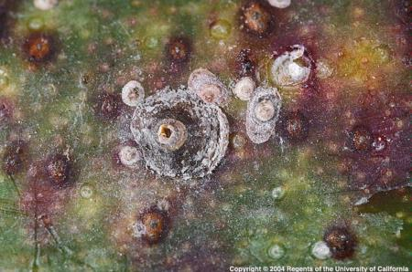
San Jose Scale (SJS) can be found feeding on limbs, fruit wood, spurs, leaves and fruit. Damage is caused by sucking plant juices from the plant and excreting a toxin while feeding. This can weaken the tree and scar the fruit. Female scales are round and have a hard grey covering (fig. 1 center). Male scales are oval (to the right of the female in fig. 1) and when adult males emerge they are yellow and winged. They can be distinguished from the yellow Aphytis scale parasitoid by a black band across the abdomen. First instar crawlers are yellow and are very small.

European Fruit Lecanium (aka. brown apricot scale) is a large domed soft scale that lays its eggs under the cover of the female scale.
Fig. 1, San Jose Scale ( photo Jack Kelley Clark)

Italian Pear Scale is the smallest scale and is often difficult to see because they hide under lichen. You can identify them by scraping the lichen off and seeing the reddish brown female scale bodies underneath.

 | Number of infested spurs with San Jose Scale
Sample number | Stop sampling | Treat | Keep sampling
First 20 spurs | 0 | 4+ | 1-3
First 40 spurs | 1 | 6+ | 2-5
First 60 spurs | 3 | 8+ | 4-7
First 80 spurs | 5 | 9+ | 6-8
100 spurs | 9 | 10+ | -
Monitoring and treatment decisions
Scale is best monitored in the dormant season by spur sampling. Collect 100 spurs from the orchard choosing older spurs from the interior of the tree. Look for scale using a hand lens or dissecting microscope. Count scale infested spurs and also look for parasitized scale. This is indicated by a small exit hole on the top of the scale. If in the first 20 spurs, 4+ infested spurs are found, treatment is needed. If less than 4 infested spurs, then continue looking at the next 20 spurs.

When is a no treatment decision reached? See table 1 for treatment thresholds. Aphid eggs should also be counted while doing spur sampling. If any aphid eggs are found then a dormant treatment is recommended. For more information on monitoring throughout the year and treatment decisions go to http://www.ipm.ucdavis.edu/PMG/r606900511.html
Table 1. Treatment Thresholds for San Jose scale ( table copied from the UC IPM guidelines www.ipm.ucdavis.edu)

Natural enemies of scale insect and keeping the balance
Although treatment is sometimes needed when the scale infestation is heavy, more often the naturally found scale predators (lady beetles and lace wings) and parasitoids (Aphytis spp. and Encarsica permiciosi) keep the scale population under control. Timing of pesticide use and the type of pesticide you choose can negatively affect the natural balance between the scale and its enemies. See Table 2 for a summary of pesticides and the impact they have. Dormant and bloom timing has the least effect over all and in-season timing can do the most harm. But dormant pyrethroids or spring applied spinosad has a greater effect on scale natural enemies than other pesticide choices or oil used at the same time. Sprays applied in-season can affect parasitoid populations and may increase the need to monitor and treat for scale in the following year. Natural enemies help reduce pesticide use so promoting the best conditions for them to thrive by carefully thinking out all aspects of pesticide choice will be time saving and economical in the long run.

Natural Enemy | Dormant |  |  |  |  | Bloom Time |  |  |  | In-Season
Natural Enemy | Oil | Oil+ pryrethroid¹ | Oil+ OP² | Oil+ IGRs³ | Oil+ spinosad | Bt⁴ | IGRs³ | Oil | spinosad | IGR⁵ | OP² | Pyrethroid¹ | spinosad | Carbamate⁶ | Oil | Neo-nicotinoid⁷
Lacewings | L | L | M | L | L | L | L | L | L | M | M | L-M | L-M | H | — | M
Lady Beetles | L | L | L | L | L | L | L | L | M | L | H | H | H | H | — | —
Minute pirate bugs | L | M | M | L | L | L | L | L | L | L | H | H | H | H | — | —
Scale Parasites | L | H | L | L | L-M | L | L | L | H | M | H | H | M | H | — | H

Table 2. Relative Impact of the Timing of Pesticide Applications on Natural Enemies (Source: UC pest Management Guidelines; www.ipm.ucdavis.edu/PMG/r606900311.html)
H = high M = moderate L = low — = no information
¹ pyrethroid (e.g. Asana, Warrior)
² OP = organophosphate (e.g. Diazinon, Guthion, Imidan, Lorsban, Supracide)
³ IGR = insect growth regulator (Dimilin, Intrepid, Esteem, Seize, Centaur)
⁴ Bt = Bacillus thuringensis
⁵ Inseason use of some IGRs (e.g., methoxyfenozide-Intrepid) has a reproductive impact on parasites and lacewings
⁶ carbamate (e.g. Sevin).
⁷ neonicotinoids (Actara, Provado, Assail)
⁸ inseason use of OPs on aphid parasites: Diazinon = M, Imidan = L, Lorsban = —
⁹ inseason use of pyrethroids on aphid parasites: Asana = L, Warrior = —

Prune out Cytospora cankers to reduce disease
Joe Connell, UC Farm Advisor, Butte County and
Franz Niederholzer, UC Farm Advisor, Sutter/Yuba Counties

Dormant pruning renews fruit wood, moderates a heavy crop, and reduces limb breakage, potassium deficiency, small fruit sizes and high dry away ratios. It is also the first step toward eliminating cytospora cankers and the dead wood associated with them. To identify limbs killed or weakened by cytospora cankers, look for dark, sunken cankers on the bark of limbs showing dieback or branches where dead leaves are still attached. Cankers will have distinct zonate margins (Figure 1) that are different from the streaking and flecking in the tissue that is characteristic of bacterial cankers. Small white spots called pychnidia found on dead wood will confirm the presence of Cytospora.

Pruning out diseased limbs and burning them will reduce disease pressure and spores that can spread disease to new wood next season (Figure 2). Be sure to cut into healthy wood several inches to one foot below any canker symptoms. Check the cut surface of damaged limbs to ensure that all disease has been removed (Figure 3). Incomplete canker removal wastes time and money and won’t control the disease. In older blocks where cytospora is a real problem, consider a using a specially trained pruning crew dedicated to identifying and cutting out the entire cankers.

Cytospora canker is a weak pathogen caused by the fungus Cytospora leucostoma that’s spread by wind and rain to bark damaged by other stresses. To minimize this disease and the loss of fruit wood, scaffolds, and potentially entire trees, avoid in-season stress factors that predispose prune trees to disease spread such as potassium deficiency, water stress, sunburn, and subsequent borer attacks. The fungus shows maximum growth in hot temperatures around 90ºF and is particularly active in late summer to early fall. Trees planted on shallow and/or heavy textured (clay) soils are generally more likely to suffer economic damage since the disease spreads more rapidly in water stressed trees.

There are no chemical controls for cytospora cankers. To manage infection and reduce disease spread, avoid tree stress and remove cankered wood from the orchard and burn it. Prune to minimize sunburn potential, and, paint exposed trunks and scaffold crotches with white interior latex paint to further protect them from sunburn. Maintain adequate orchard water status, especially after harvest, and avoid potassium deficiency, spider mite or prune rust defoliation that can increase sunburn and disease potential.

For more detailed information on disease management and for excellent photos of disease symptoms and fungus signs that will help you know what to look for, visit the IPM web page (www.ipm.ucdavis.edu) and click on Agriculture and floriculture; Prune; and cytospora canker (under diseases).

Figure 1. Cytospora cankers are detected as sunken areas on the branch where bark has been killed. Arrows point to canker edges, revealed by a knife cut in the second photo.
Alive
Dead Spores can be spread by rain and wind and possibly by wood-boring beetles such as shot-hole borers. ead
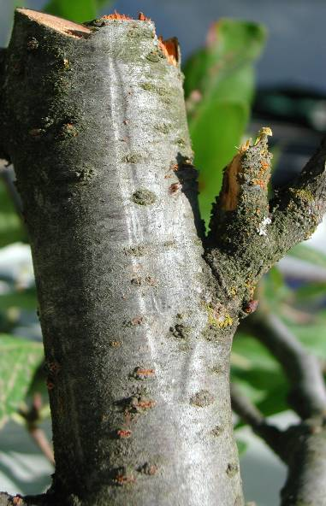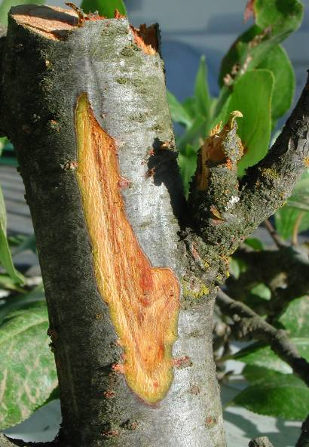

Figure 2. Pychnidia, black or white pimple-like spore producing structures found on dead wood.
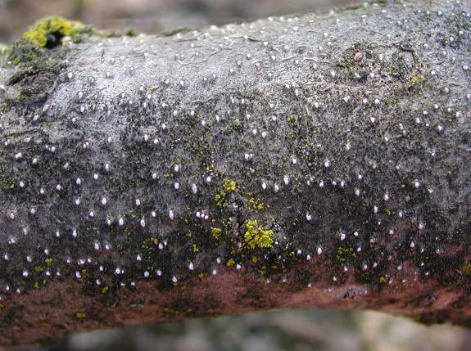

Figure 3. Good cut (1) below canker showing only clean bark. Bad cut (2) not far enough down showing diseased bark (arrows) and canker remaining in the tree.
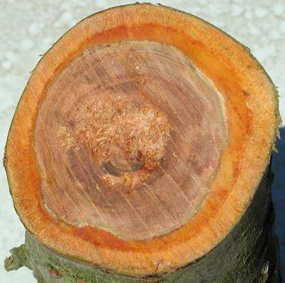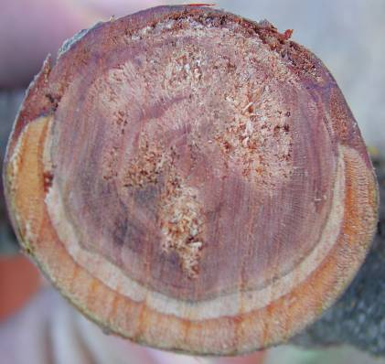
2
1

Fall Spray for Prune Aphid Management
Franz Niederholzer, UC Farm Advisor, Sutter/Yuba Counties

Prune aphids – mealy plum and/or leaf curl plum aphid – are key pests of prune. High populations of these pests can reduce tree vigor, fruit sugar content and return bloom the next year. Honeydew from feeding aphids dropped on fruit can increase cracked fruit. Effective prune aphid control – when needed – is a key to successful prune farming.

Recent University of California research shows that a fall pesticide application gives excellent prune aphid control the following season. Effective timing for this spray is late October through early December. After early December, leaves have dropped and standard dormant spray is very effective. In the fall, soils are usually dry and spraying is easier and less expensive than in the full dormant season (winter).

Not all pesticides give good aphid control in the fall spray. Research shows that pyrethroids – Asana, Warrior, Baythroid, Mustang, etc. – all give excellent control anytime between mid October and mid December. The neonicotinoid (neonic) materials – Provado (and generics), Actara, and Assail – work well in late October but don’t work well after leaves begin to drop in early November. This is because the neonic materials require uptake and translocation in the leaf to be effective on feeding aphids. Organo-phosphate pesticides – diazinon, Imidan, etc. – don’t work well for aphid control unless applied after December 1. Oil is not needed in the tank in a fall spray.

Not all orchards need a spray program for aphid control. If you have a regular history of aphid damage anywhere in an orchard, then a fall spray or dormant treatment is required to control aphids. But if you haven’t ever seen aphid damage around hard-to-cover areas near buildings or power lines following a dormant spray by air or after every-other row dormant spraying, you may not need to spray for aphid.

What happens if you miss the fall or dormant spray timing? If a late walnut harvest and/or a wet (or dry) winter keep you from a fall or dormant spray in prunes, you still have effective options for aphid control. Watch the trees for aphids after bloom. No aphids in the spring? No need to spray. If you see aphids in the orchard after bloom, you can use a range of pesticides for good control. Talk with your packer regarding which pesticide residues are accepted in the market. Talk with your PCA about materials that give good aphid control without flaring mites. Recent registrations of effective in-season aphid sprays include BeLeaf, Actara, Assail, and Provado (and generics).

What won’t a fall spray do? A fall spray is for aphids, only. It gives some peach twig borer control, no scale control, and has no affect on bloom timing. To find out if you need to control scale, take a dormant spur sample. See http://www.ipm.ucdavis.edu/PMG/r606900511.html or call your UC farm advisor for details on dormant spur sampling.

A fall spray for prune aphid control is a solid option for growers without a scale problem who are looking to control a regular aphid problem. A fall spray provides good aphid control with low cost and hassle (no mud) while avoiding in-season spray issues such as complying with “no spray” lists and flaring spider mites.

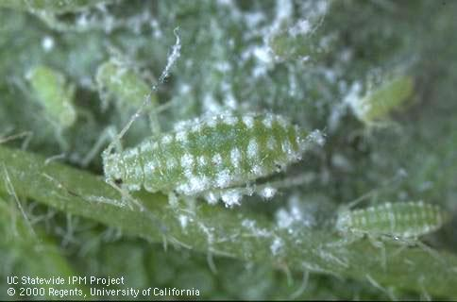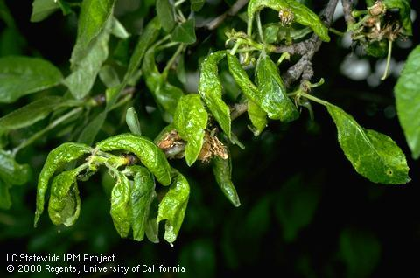
Mealy plum aphid

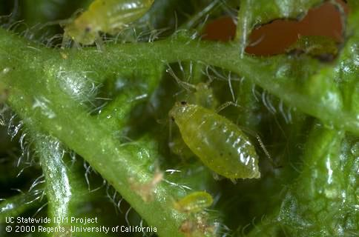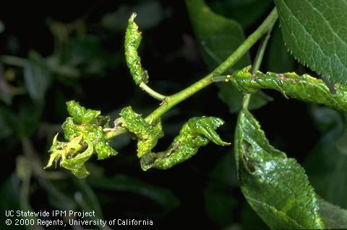
Leaf curl plum aphid

Using high oil rate before bloom: Why do it?
Franz Niederholzer, UC Farm Advisor, Sutter/Yuba Counties

A high rate of horticultural oil in a dormant spray can give significant benefits to prune growers. However, a high rate of oil can cost $20/acre or more and risks oil burn under the wrong conditions (dry orchard soil or trees), so growers should weigh the benefits against the costs.

“Horticultural oil” refers to superior or supreme oil (440 or 470), regular dormant oil, or dormant flowable emulsion (“mayonnaise”). All these materials are effective at moving bloom and controlling scale. Summer oil (415) is not recommended for dormant application. With superior or supreme 440, a “high” rate is 3-4 gallons/acre. Consider orchard conditions (Tree age, orchard moisture, etc), the product label and your PCA’s recommendation when selecting oil rates in dormant or delayed dormant prune orchards.

High rates of horticultural oil can advance prune bloom date 3-5 days when applied in late December through mid to late January. Earlier bloom can help growers avoid heat damage at bloom and can help with equipment and labor management at bloom time if a grower has several orchards and only sprays part of the trees with a high rate of oil.

A high rate of oil before bloom (alone, no pesticide) also gives good control of low to moderate populations of San Jose scale. Add a pesticide (Centaur, Seize, or diazinon) to oil in the spray tank and you get excellent control of high populations of scale. Oil is a great insecticide resistance management choice in a scale control program because it kills scale by suffocation, not by a chemical action. A dormant spur sample, taken anytime from mid-November to mid-January, will show if scale are a problem and need to be treated. Information on dormant spur sampling is available on the internet at http://www.ipm.ucdavis.edu/PMG/r606900511.html or from your local UC Farm Advisor. The best timing for scale control with oil is in the delayed dormant period. Spraying oil for scale in the full dormant timing reduces scale populations, but not as much as the delayed dormant timing.

When should oil be applied to advance bloom? A good ballpark spray window is the old standby -- late December through mid January. If you want to try to fine tune your dormant oil application, consider applying oil once a certain amount of chilling has accumulated -- 30-50 chill portions using the new Dynamic Model calculations. [This timing usually works out to being from mid-December into late January.] For information on the Dynamic Model and how to use it to time a dormant oil application to advance bloom, see information on the internet at:
http://fruitsandnuts.ucdavis.edu/Weather_Services/ and click on “Prune Chilling Prediction Model”.

So, heavy oil can be used to advance bloom in the dormant period but gives best scale control when sprayed in the delayed dormant. When should you spray a heavy oil rate in a prune orchard? It depends on the biggest concern in an orchard – bloom timing or scale. If a grower’s primary concern is advancing bloom, then spray in the dormant period. This timing will also provide good scale control. If scale control is the biggest concern, apply oil during the delayed dormant period. This timing has less risk of oil burn, but will have little effect on bloom timing.

Short, timely prune updates available

Short, timely updates on prune production are available to cell phones and computers via Twitter. Go to www.twitter.com/prunedoc to sign up. Message topics in the last month include:

- Sept 22: Hot weather coming, look out for sunburn on dry trees
- Sept 16: Topping + zinc sulfate helps reduce blow over
- Sept 16: After Oct 20, add a pyrethroid to zinc sulfate: get aphids for next year + drop leaves.
- Aug 26: 20% chance of rain on Aug 28, watch out for late brown rot infections
- Aug 23: YC prunes averaging 3.5 lb and 23.5% sugars

If you have unlimited texting on your cell phone plan, getting these messages on your cell phone won’t cost you extra. I’ve averaged about 4-8 messages per month this summer.

Upcoming Meetings:

Date | Event | Location | Contact
October 5 | Kill the Bug, Recycle the Jug | Davis Machine Shop, Meridian | 822-7503
October 29 | Citrus Research Growers’ Education Seminar* | Auburn Veterans Memorial Hall (lunch included) | (559) 738-0246
November 10, 18, Dec. 7, 9 | Sutter Co. Fall Grower Meetings | Sutter Co. Ag Building | 822-7503
December 2 | CAPCA/CCA CE meeting* | Sutter Co. Ag Building | 822-7503
*There is a fee to attend this meeting

ANR NONDISCRIMINATION AND AFFIRMATIVE ACTION POLICY STATEMENT FOR UNIVERSITY OF CALIFORNIA PUBLICATIONS REGARDING PROGRAM PRACTICES
The University of California prohibits discrimination or harassment of any person in any of its programs or activities. (Complete nondiscrimination policy statement can be found at http://groups.ucanr.org/ANR_AA/files/54635.doc). Direct inquiries regarding the University’s nondiscrimination policies to the Affirmative Action Director, University of California, ANR, 1111 Franklin St., 6th Floor, Oakland, CA 94607, (510) 987-0096. 07-2008.

