Pre-Harvest & Harvest Prune Orchard Considerations
In This Issue

- Prune Orchard Considerations

- Phellinus wood rot, or “Why do my trees blow up at harvest?”

- Making money at harvest

- What are you doing for your orchard’s financial longevity?

- New Staff Research Associate!

Franz Niederholzer
UCCE Farm Advisor
Sutter, Yuba, and Colusa Counties

Jaime Ott, UCCE Orchard Advisor, Tehama, Shasta, Glenn, and Butte Counties

The prune crops look good so far. With the market where it is and a heavy crop in many orchards, prunes are worth putting money into this year. Maximize that benefit by keeping those trees healthy and the fruit sizing well.

July
- Prevent defoliation: Healthy leaves = healthy crop. Continue monitoring for preharvest outbreaks of rust and spider mites. Where needed, controlling these pests also helps limit leaf trash in the bins at harvest.
- Fruit brown rot: Clustered fruit is more vulnerable to brown rot infections as harvest approaches. You might consider an “insurance” spray with an effective fungicide this year to protect your investment.
- Monitor fruit maturity: Harvesting fruit before it’s ready loses money. Watch the fruit to know when to expect mature fruit and start of harvest. Fruit matures roughly 30 days after the first color shows on the suture. Begin measuring fruit internal pressure once fruit shows color.
- Take July leaf samples to inform this season’s potassium (K) levels and next year’s fertilizer program. Leaves under 1% K are deficient and could result in damage and crop loss this season. To correct K levels this season, fertigation (KTS, liquid MOP, potassium carbonate, etc.) or foliar applications (potassium nitrate) should be used. See this article for more information about potassium management.
- Irrigate carefully: stressed trees = smaller fruit. Using a pressure chamber, maintain trees at -12 to -16 bars to prevent both over- and under-watering.
- Clean up orchard ahead of harvest for faster operation.
- Consider pruning out dead wood during the dry weather.

Pre-Harvest
- Monitor fruit maturity: Harvest when fruit internal pressures are 3-4 lbs. Pressure, and not accumulated sugars, determines when fruit are ripe. Using pressure to determine harvest timing gives you the highest dry weight, the highest quality, and the best returns. See this article for more information.
- Examine fruit pre-harvest to evaluate the efficacy of your IPM program. Two to four weeks before harvest, evaluate 40 fruit per tree from 25 trees throughout the orchard for worm, scale, and brown rot damage. Evaluating only at harvest misses any damage which caused fruit to drop early.
- Time your irrigation cut-off to improve dry-away ratio, reduce fruit drop, and decrease shaker damage during harvest. Using a pressure chamber, target -16 to -20 bars in the last week or two before shaking. Trees on Krymsk 86 rootstock may need more time to
dry down sufficiently to prevent shaker damage to the bark.
- Field sizing: Sending undersized fruit to the dryer takes money out of your pocket. Reduce drying costs by running at least a small sizer (15/16-inch), which removes garbage and damaged fruit. Small and medium fruit are much less valuable than large fruit: double check with your packer about dried fruit value by screen size to help decide if a larger sizer (1” or larger) makes sense. If you run a sizing chain, make sure the receiver belts run slowly enough to allow all the fruit to run directly over the chain for proper sizing. You also want to keep your sizing chain clean by washing down with water during breaks.
- Remove trash from your bins during harvest. If you send too much “junk” (dead branches, garbage, etc.) to the dryer, they will charge you more for drying.

Post-Harvest
- Manage post-harvest irrigation to minimize water stress. After harvest, maintain the trees between -12 and -16 bars. Cytospora canker grows faster in orchards under severe water stress.
- Fall nutrition program: Consider your July leaf sample results and crop load to guide fall nutrient decisions. If nitrogen levels in the July leaf sample are below 2.2% N consider applying a fall foliar nitrogen spray. This is especially important for young orchards where low nitrogen can predispose the trees to bacterial canker. It is not recommended to apply soil nitrogen in the fall, as root uptake is low and much of the nitrogen will be lost by leaching. For potassium management, it is important to consider the size of the crop just harvested. Prune fruit uses most of the potassium applied to trees and contains 30 lbs K₂O per ton of dried fruit at harvest. Potassium to support next year’s crop can be effectively applied to the soil by banding in the fall. CDFA fertilization guidelines have more information on rates and effective delivery methods for nitrogen, phosphorus, potassium, and zinc.
- Plan for pruning to remove Cytospora cankers, remove branches damaged during harvest, control tree size, and limit next year’s crop load. Avoid pruning within the two weeks prior to a rain event. A timely application of Topsin-M® or generic option (as soon as is feasible after pruning and before rain) is the best way to protect pruning wounds. See the article in this newsletter for more information.
- Scout for weeds to evaluate your weed control program. Pre-emergent herbicide should be applied shortly before a moderate rain event (0.25”) or irrigation to move the material into the soil. Avoid applications prior to a large rain event (>1”), which will move the product too deep in the soil for good weed control.
- Monitor (and treat) for insect pests. Fall and winter can be a good time to do preventative treatment for aphids in orchards with a history of problems. After leaf fall begins, use dormant spur samples to scout for San Jose scale, European fruit lecanium, aphid eggs, European red mite eggs, and evidence of parasitism on these pests. This helps to determine if a dormant spray is needed, and what materials should be used. See ipm.ucanr.edu/agriculture/prune and sacvalleyorchards.com/prunes/insects-mites-prunes for more details.
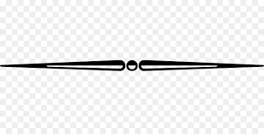

Phellinus wood rot, or “Why do my trees blow up at harvest?”
Laurel Hoffman, UC Davis Dept. of Plant Pathology PhD Graduate Student, Rizzo Lab, Hoffman@ucdavis.edu

California's prune industry faces a significant challenge: a decline in orchard lifespan. Average productive life has shrunk from an estimated 30 years in 1998 to just 20 years as of 2022 (UC Cost and Return Studies). Heat stress, repeated mechanical damage, and disease are likely contributing factors. A primary disease culprit associated with premature orchard decline is the loss of fruit-producing scaffolds likely caused by the heart rot fungus Phellinus pomaceus (formerly called P. tuberculosus).
Phellinus pomaceus specifically targets Prunus spp., unlike most wood decay fungi which have a broader host range. This fungus is common in natural forests of Europe and Asia. It invades the heartwood, causing white rot that weakens branches. In California prune trees, this results in broken branches that reduce fruit production. Additionally, weakened trees become more susceptible to other stressors, ultimately shortening orchard lifespan.
Prune growers should be aware of the signs of Phellinus pomaceus infection. Look for shelf-like fruiting bodies (conks) on trunks or branches (see photos below) – these are the fungus' reproductive structures and indicate established infection. Additionally, broken or pruned branches with exposed white rot decay (also pictured below) can indicate the disease. Growers often discover this internal heart rot in major scaffolds leading up to and during harvest, when branches that appear healthy snap under the weight of fruit or during shaking– aka “blowing up.”
Our research in investigating Phellinus pomaceus and developing management strategies is supported by funding from the California Prune Board. We are focused on investigating several key areas:
Distribution of the fungus, its impacts, and management choices: We are surveying prune orchards to assess the prevalence and severity of infection statewide and investigating potential links between disease occurrence and factors like pruning practices, irrigation types, spray applications of dormant oils, the presence of other pathogens, and local weather conditions. Surveys in mature prune orchards reveal a high prevalence of Phellinus pomaceus infection levels in the Sacramento Valley compared to historical studies, with all surveyed contemporary orchards over 14 years showing signs of the infection. Conversely, extremely limited infection has been observed so far in the San Joaquin Valley. Weather stations have been installed in 10 orchards from Red Bluff to Madera since Fall 2023 and provide specific in-orchard conditions that may be related to the progression of the disease.
Additionally, we are collaborating with researchers in France and South America to see if Phellinus pomaceus is a problem in other major prune-producing regions. Surveys in Chilean prune orchards are planned for September 2024 with additional funding from UC Davis Chile Life Sciences Institute.
Potential Control Methods: Since there is currently no known chemical control for Phellinus pomaceus, we are exploring bio-control alternatives. Two trials are underway to investigate the potential of Trichoderma spp. (a beneficial fungus used as a bio-control product in other crops, one trade name is Vintec®), to protect pruning wounds from Phellinus pomaceus infection. The first trial is a multi-year project (started in 2020) wherein orchard blocks have been sprayed with Trichoderma products annually and disease progress is being monitored. Due to the slow progression of this disease, results will not be clear for many more years. The second trial is direct application on fruiting bodies to observe any effects on growth and spore production. After a single season in this trial, unfortunately Phellinus appears unhampered in its life cycle – though these results are still pending. A third trial is upcoming and will consist of targeted pre-inoculation of fresh pruning wounds with different combinations of Phellinus pomaceus spores and Trichoderma bio-controls and re-sampling a short time later to observe disease progression in the presence of these alternative spray applications.
Spore Dispersal and infection routes: Understanding the life cycle of fungal pathogens is crucial for disease prevention, though current literature is lacking in relevant studies on Phellinus pomaceus. We are working to understand how the disease colonizes and spreads in California prune orchards. Recent dissection of infected trees indicates the primary route of infection is through pruning wounds, which are colonized by airborne spores released by the fungus during specific windows.
We are monitoring airborne fungal spores in orchards throughout the year to identify these peak periods of Phellinus pomaceus spore dispersal. This information can help growers time pruning activities to minimize infection risk. Initial results show peak spore production in late January to early April, depending on the region. These data currently support orchard managers to avoid pruning during this time, when chances of infection are
likely highest. More official data will be coming in the next year.
We will continue to share our findings and develop management recommendations for growers. Stay tuned for future updates on the completion of orchard surveys and the impacts of orchard management practices, the results of Trichoderma spp. trials, and how our growing understanding of the life cycle of Phellinus can improve management of the disease. We are grateful to the California Prune Board for generously funding this important research.
Please reach out to Laurel Hoffman, PhD Graduate Student in the lab of Dr. David Rizzo of the UC Davis Dept. of Plant Pathology if you have concerns or questions about this research at Hoffman@ucdavis.edu.
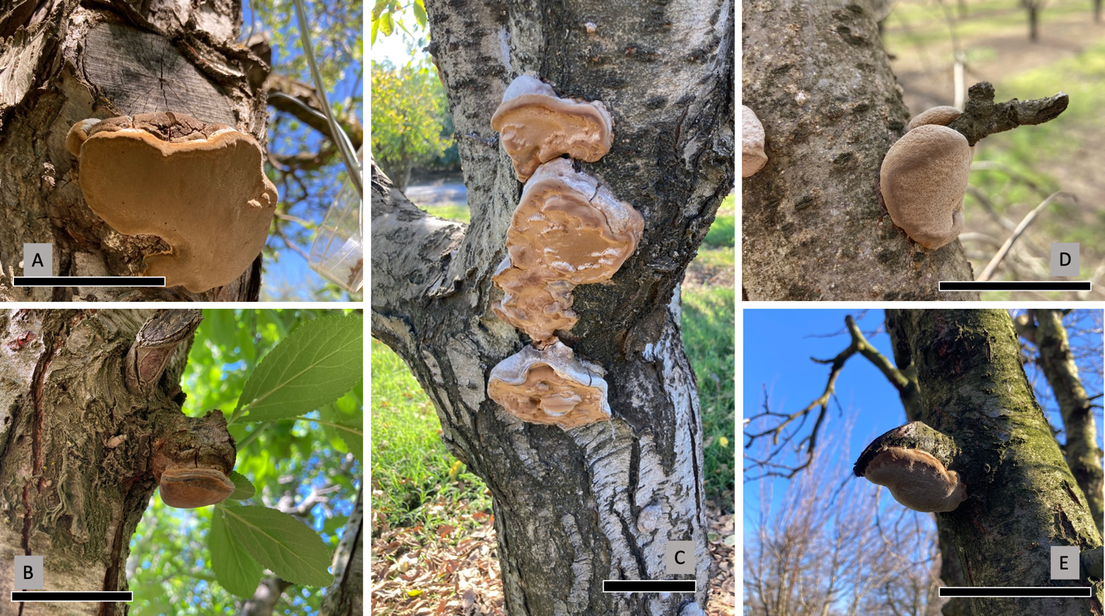

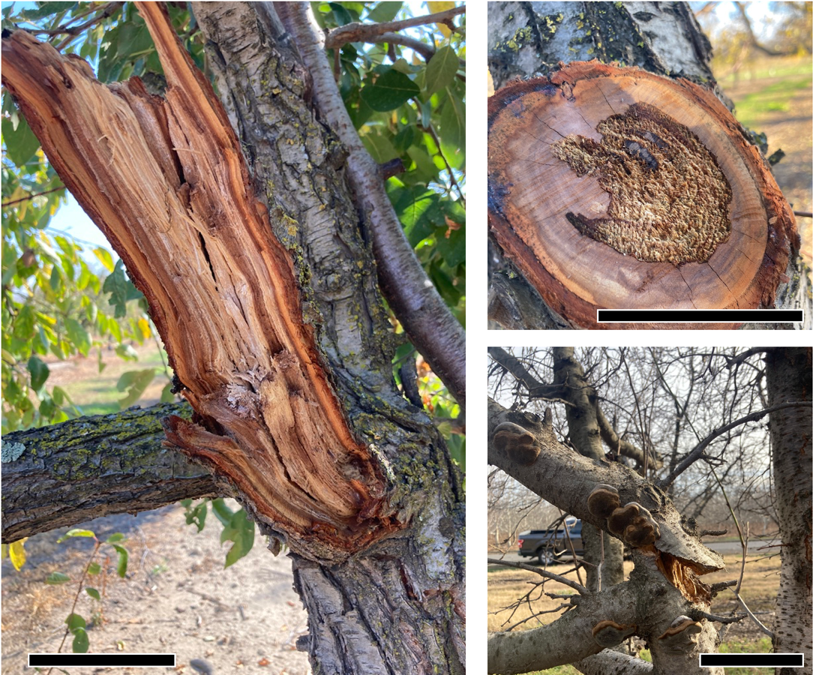
Figure 1. Fruiting body of Phellinus pomaceus. Characteristic association with pruning wounds shown in A, B, D, E. Scale bars 10 cm (4 inches).

Figure 2: Symptoms of advanced Phellinus pomaceus infection, showing white rot internal decay of heartwood. Scale bars 10 cm (4 inches).
Making money at harvest
Franz Niederholzer, UCCE Farm Advisor, Colusa and Sutter-Yuba Counties

Sustainable net return to grower is the measure of success in farming. Because profit margins shrink with increasing costs, small income increases (that don’t impact overall orchard health) can have major benefits to an operation’s bottom line. This was the point of the recent article by Domena Agyeman (newly arrived UCCE Area Ag Economist) regarding the 5% approach to farm management. (To see the newsletter issue containing that article click HERE.) As the harvest approaches, growers have a good opportunity to use the 5% plan to increase profitability without increasing costs. On the surface it’s simple: don’t harvest too early and run a sizer.

When is too early to harvest? Before fruit has reached 4 lbs fruit pressure. Fruit receive sugar from leaves up to fruit maturity (4 pounds internal pressure). Higher sugar in the fruit means lower dry away ratio. (See table for an example of how lowering dry away improves grower income.) After maturity, fruit lose water, increasing percent soluble solids and so continuing to improve dry away and return to grower. Harvesting too early often means fruit contains lower sugar concentration and, therefore, higher dry aways after drying. This costs the grower money.

*******************************************************************************

An example of the impact of dry away ratio on grower income per acre given a set quantity of fruit is delivered and dried. Assume $175/green ton drying costs and $2000/dry ton crop value.

Green: Dry fruit ratio  (“Dry away”) | Green tons/acre | Dry tons/acre | Gross Crop Income ($)  per acre after drying costs*
3.1 | 10.5 | 3.39 | 4962
3.0 | 10.5 | 3.50 | 5162
2.9 | 10.5 | 3.62 | 5404
2.8 | 10.5 | 3.75 | 5662
2.7 | 10.5 | 3.89 | 5940

*Example calculation: at 3.0 dry away, total income per acre is $7000 ($2000/dry ton x 3.5 dry tons/acre = $7000). Total drying costs are $1837.5 (10.5 green tons/acre x $175/green ton=$1837.5). Subtract drying cost from income to give “Gross Crop Income” = $5162. (The final value is rounded up to the next highest whole dollar.)

*******************************************************************************

When is the best time to start harvesting? In my opinion, the best timing for harvest is when orchard average fruit pressure is at 3 pounds. At this average pressure, all the fruit should be below 4 pounds and so fully mature. Using 3 pounds pressure as the “go” trigger, and the average pressure drop of one pound per week, a grower should have a two-week window to harvest the crop between optimum maturity and super soft fruit (<1 pound pressure) with potential quality issues such as darkened flesh and gas pockets. [At the very earliest, harvest should start when the average fruit pressure is 4 pounds.]

Small fruit has little value to the grower and often has low sugar, making it even less valuable as drying costs are higher for small, low sugar fruit. Undersized fruit is even worse—you are charged for drying but receive no payment for it. Eliminate small and undersized fruit from bins by carefully sizing at harvest. This means running fruit over an appropriately sized chain (1-1.25”) at a belt speed slow enough to keep fruit at a single layer on the sizing chain. If the fruit isn’t sitting on the chain, but resting on other fruit, it can’t be sized, and small fruit can end up in the bin.

To maximize income in tough economic times, harvest timing and operation should be carefully reviewed. There may be a significant cost (lost income) if harvest starts too early and equipment is run too fast. Growers should consider reviewing their harvest operations, especially start timing and equipment settings, and make an “eyes wide open” decision regarding when harvest begins and how it is done.
What are you doing for your orchard’s financial longevity?
Luke Milliron, UCCE Orchard Advisor Butte, Glenn, Tehama
Franz Niederholzer, UCCE Farm Advisor, Colusa, Sutter, and Yuba Counties

Your orchard is an investment – the longer it remains a productive, high-yielding orchard the higher your return on that investment and the longer you can avoid the (very expensive) need for orchard removal, replanting, and years of non-bearing and low initial yields.
Do you know what thiophanate-methyl is? It is the active ingredient in the fungicide Topsin-M®. While this is not a pesticide advertisement or recommendation, research from the lab of Dr. Themis Michailides (UC Davis, based at Kearney Ag Research & Extension Center) has shown that Topsin-M® is the most consistently effective fungicide for protecting fresh pruning wounds. Pruning wounds are very easily colonized by canker causing fungi (Cytospora, Botryosphaeria, and others). These fungi infect the fresh pruning cut with wind splashed spores during rainstorms.
So, all you must do is prune, quickly clear the brush, and apply Topsin-M® or another thiophanate-methyl product? Unfortunately, it’s not quite that simple. Although this fungicide is the best protective spray we have to date, it significantly reduces but does not prevent all canker infections that can shorten your orchard’s lifespan. Still, to give your orchard the best shot at long sustained health and financial viability -integrate this spray in with other best practices:
- Skip pruning when you can (following a heavy crop, the year after detailed pruning, etc.), but make sure to shaker thin if a heavy crop sets because limb breakage is also an opportunity for canker infection.

- Prune around rain whenever possible. Early fall or after bloom are pruning timing options that may (should?) avoid rain. Never prune with rain in the forecast.

- Quickly push brush and consider spraying with a thiophanate-methyl product (Topsin®-M, etc.).

- Prune out and remove dead wood in the orchard to reduce canker inoculum. Burn pruning debris where permitted.
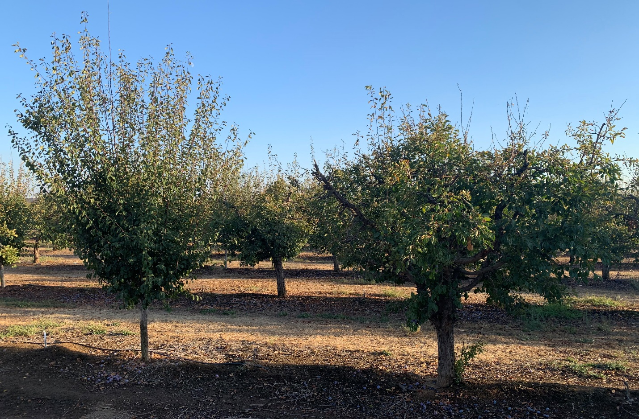
Photo contrasting tree age and health: Young, healthy tree (left) and canker damaged tree (right). To reduce chances of the left tree looking like the right tree in the future, protect pruning wounds with a thiophanate-methyl (Topsin®-M, etc.) fungicide as soon as possible after pruning and before rain (photo by Franz Niederholzer).
*Note, Mention of any chemistries or trade names does not constitute a recommendation and are for informational purposes only. Always consult with your PCA before use and adhere to the pesticide label and local and state regulations.
New Staff Research Associate

Jocelyn Alvarez joined UC ANR in 2024 as a Staff Research Associate serving orchards in the north Sacramento Valley with Curt Pierce and Becky Wheeler-Dykes in Glenn County, as well as the advisors in Butte and Tehama Counties. Jocelyn is a first-generation college student from Santa Maria, CA. She graduated with a B.S. in Wine and Viticulture in 2021 and a M.S. in Agriculture specializing in Crop Science from Cal Poly San Luis Obispo in 2023. She is focusing on research and learning more through new experiences to be able to contribute to future growing decisions and innovations. She enjoys hiking, traveling, spending time with family, and looking for new places to eat and explore. She will be based at the Glenn County Cooperative Extension office. Her position is generously funded by the California Walnut Board and Commission, Almond Board of California, California Prune Board, and the California Pistachio Research Board.

