University of California Cooperative Extension

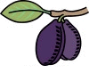Sacramento Valley Prune News
A Regional Newsletter of the UC Cooperative Extension Prune Advisors
In This Issue
Suggested Prune Orchard Activities in July
- Field Sizing French Prune
- Sutter Harvest Parameters: Suggestions for 2008 and a look at ongoing testing
Estimation of French Prune Harvest Date in the Sacramento Valley
Managing Fruit Brown Rot in Prunes
Blue Prune Drop and Leaf Scorch

Suggested prune orchard activities in July

- Measure fruit pressure once color first shows in healthy prunes. Fruit firmness (pressure) is the best measure of crop maturity and harvest timing. When will harvest be this year? Harvest should be a week later than usual this year in Sutter/Yuba area, but don’t take my word on it. Measure fruit pressure to truly know what’s going on in the most important orchard in the state -- yours. When first color appears, fruit are generally about 20-30 days away from maturity. Fruit generally lose 1-2 pounds of firmness per week. Cooler weather means fruit soften faster, hot weather slows fruit maturity. See articles in this newsletter on prune harvest prediction and Sutter variety maturity.

- Consider running a field sizer on your harvester this year. The price for certain sizes of small prunes in 2007 was below drying cost. Delivering that fruit to the dryer this year will cost you money. See article on field sizing in this newsletter. Check with your processor regarding prices or expected prices. What fruit will be worth what? KEY POINT: Don’t rely only on fresh fruit size when deciding what size chain to run. Know your sugar levels at harvest and use this information to select chain size. Why? Sweeter fruit dries to a larger count prune than fruit of the same fresh size, but less sugar. For example: a fresh prune with 28% sugar will be 8-13 counts larger when dried to 18% moisture than a fruit of the same fresh size, but with 20% sugar.

- Preharvest irrigation water shut off. Properly timed irrigation cut off will help reduce 1) bark damage from shakers, 2) fruit dry-away ratio, and 3) premature fruit drop. Use fruit pressure information to predict start of harvest (fruit drop about 1-2#/week; idea harvest pressure = 3-4# pressure) and then use that date to decide when to cut-off irrigation water before harvest. UC research and experience in this region in 2006 shows that healthy prune trees can sustain water cut off for up to six weeks before actual harvest. Grower experience should determine when irrigation water is cut off in a specific orchard. If spider mite pressure is building right before harvest, consider a potassium nitrate spray to “top off” the potassium levels in the trees and suppress adult spider mites for 2-3 weeks.

Newsletter Submitted By:

Franz Niederholzer
Sutter Yuba Counties UCCE
Orchard Systems Farm Advisor

Bill Krueger, Glenn County
UC Farm Advisor

Richard Buchner, Tehama County,
UC Farm Advisor

Jim Adaskaveg, UC Riverside
Professor, Plant Pathology

Carolyn DeBuse, Solano/Yolo Counties
UC Farm Advisor

e University of California prohibits discrimination or harassment of any person on the basis of race, color, national origin, religion, sex, gender identity, pregnancy (including childbirth, and medical conditions related to pregnancy or childbirth), physical or mental disability, medical condition (cancer-related or genetic characteristics), ancestry, marital status, age, sexual orientation, citizenship, or status as a covered veteran (covered veterans are special disabled veterans, recently separated veterans, Vietnam era veterans, or any other veterans who served on active duty during a war or in a campaign or expedition for which a campaign badge has been authorized) in any of its programs or activities. University policy is intended to be consistent with the provisions of applicable State and Federal laws. Inquiries regarding the University’s nondiscrimination policies may be directed to the Affirmative Action/Staff Personnel Services Director, University of California, Agriculture and Natural Resources, 300 Lakeside Drive, 6th Floor, Oakland, CA 94612-3550, (510) 987-0096. 1/04

Page 2, Sacramento Valley Prune News, August 2008

- Preharvest brown rot sprays may reduce fruit brown rot in orchards where brown rot has been a problem. See article in this newsletter.

- Monitor blocks for spider mites, rust, and water status.

- Clean up orchard before harvest. Cut out dead and dying limbs, suckers, etc. prior to harvest. This will reduce harvester and/or tree damage and make for a faster, cleaner harvest.

- Take leaf samples in July. Call Franz for UC recommendations for interpreting prune leaf analysis results.

Field sizing french prune
Richard P. Buchner UC Farm Advisor, Tehama County

Undersized prunes have marginal, if any, value and usually represent a net loss because of costs to haul, dry and market order payments for prunes with little or no value. Several methods are available to regulate cropping and encourage larger fruit size. Pruning, mechanical thinning, cultural practices and field sizing at harvest, are some of the possibilities. Crop control during the season is the preferred method because the tree does not have to invest resources in producing prunes with little or no value. Field sizing at harvest is a last resort and by no means a substitute for in-season crop sizing techniques.

Harvest sizing to eliminate undersized prunes is not a new idea. Tulare County Farm Advisor Steve Sibbet did some of the first evaluation in 1986. Buchner et. al evaluated harvest sizing in Tehama County in 1996, 1997 and 1998. Our experience with harvest sizing is based upon those experiments. The goal of field sizing is to improve the value of the remaining fruit enough to exceed any value from the weight loss due to removing undersized prunes. In 1997 we evaluated a one inch bar sizer and improved profitability $10.39 per dry ton. Success depends upon selecting and maintaining the correct chain or bar size for individual harvest conditions. Watch what's going on the ground and adapt accordingly. Here are several suggestions/cautions for separating out undersize prunes.

- Sugar and pressure. As fruit accumulates sugar and softens, a sizer is more likely to remove fruit with value.
- Price schedule affects the value of removed fruit. Decide which sizes to remove and select the correct opening to remove target prunes. Be prepared to change or remove sizers as fruit conditions change.
- How much undersized fruit needs removal? If the amount of undersize fruit is relatively small it may not be economical to invest time and energy to remove it.
- If harvest speed is reduced and/or custom harvest costs increase, it may not be a good choice to remove undersize fruit.
- Harvest timing. High sugar prunes are more likely to have value.
- Equipment logistics. Flexibility is necessary when using sizers. They need to be kept clean to function properly. Overloaded sizers cannot be expected to work properly.
- Growers who use harvest sizers to remove undersized prunes need to carefully monitor discarded fruit particularly if larger size openings are selected. Larger openings are more typical early in the harvest. As harvest progresses, sizer openings are often decreased or sizers are completely removed.
Page 3, Sacramento Valley Prune News, August 2008

Sutter harvest parameters: suggestions for 2008 and a look at ongoing testing
CAROLYN DEBUSE, UC FARM ADVISOR, SOLANO AND YOLO COUNTIES

The new prune variety Sutter is in its early years of commercial planting. After Sutter’s release in 2000, orchards were planted throughout the prune growing areas of California effectively improving our experience with how the variety performs. The variety has several positive attributes. First, Sutter is a high sugar prune averaging 2 ° Brix higher than French grown at the same location. In addition, Sutter harvests 7-10 days earlier than French allowing growers to spread their harvest. Presently, the oldest orchards are 5th to 6th leaf and just starting to come into full bearing. With harvest approaching, it is a good opportunity to discuss what we have observed from previous harvests and make suggestions for 2008.

Growers have been harvesting Sutter using the same harvest parameters as French starting when average fruit internal flesh pressure is 3-4 PSI. In 2006 and 2007, we observed that French harvest parameters do not work well for Sutter. Sutter harvested at this pressure was found to slab and bleed on drying trays making it hard to clean trays resulting in an unsuitable dried fruit. When Sutter is harvested at ‘ higher pressure ’ it dries well resulting in a high quality prune.
A cooperative effort is underway with Sunsweet, UC Dried Plum/Prune Development Program and UC Cooperative Extension working together to fine tune Sutter’s harvest parameters and drying protocol. The experiment will include three harvests at different flesh pressure, 7-8 PSI being the highest and 2-3 PSI being the lowest. For each harvest, Sunsweet will dry half of the fruit at normal drying temperatures and half the fruit at a lower temperature using a longer drying time. A dried quality evaluation will assess the best harvest time and drying practice.
Sutter Growers: In planning Sutter harvest, test fruit pressures at frequent intervals after the fruit has reached full color so that you will not miss your optimal harvest timing. Harvest at a higher pressure than you have previously done with French. My best estimation is to harvest Sutter when fruit pressures are in the 5-7 PSI range.

Estimation of french prune harvest date in the sacramento valley
CAROLYN DEBUSE, UC FARM ADVISOR, SOLANO/YOLO COUNTIES

Planning harvest can be challenging when you watch the weather and try to compare this year to other years while only feeling sure of your estimation as harvest nears and fruit pressures drop. To make it easier, a new harvest prediction model that uses growing degree hours accumulated in the first 30 days after bloom (GDH30) can be used to predict harvest date. Table 1 shows the model’s estimated harvest dates in the Sacramento Valley using collected bloom dates from different counties, weather data from that county’s CIMIS station and the GDH30 calculator from the ‘Fruits and Nuts Research and Information Center’ website. The overall picture for this year suggests cool temperatures following bloom lengthened the fruit development time which will delay harvest by a week or more.
*Note that your weather conditions and microclimate could be cooler or warmer than the weather near the CIMIS station used for this estimation. Included in the table are two Solano areas that are near each other but have very different spring temperatures.

Page 4, Sacramento Valley Prune News, August 2008

What does this mean to you?
- Plan for a later harvest
- Don’t be too eager to turn off your irrigation to dry trees for harvest
- Don’t feel pushed to harvest when your sugars are low and your pressure is still above 4-5 PSI

More information on the ‘Harvest Prediction Model’ can be found at http://fruitsandnuts.ucdavis.edu/files/49108.pdf

Table 1. Estimation of French prune harvest date in the Sacramento Valley for 2008. Estimations were made using the ‘Improved French Harvest Prediction Model’
County | Full bloom date | GDH30ª | Estimate of number of days to maturity | Estimate Harvest Date
Tehama | 18-Mar | 5,903 | 165 | 31-Aug
 | 23-Mar | 5,794 | 167 | 7-Sep
Butte | 18-Mar | 6,221 | 164 | 30-Aug
 | 23-Mar | 6,172 | 164 | 4-Sep
Glenn | 19-Mar | 6,240 | 164 | 31-Aug
 | 23-Mar | 6,050 | 165 | 5-Sep
Colusa | 16-Mar | 6,102 | 164 | 28-Aug
 | 23-Mar | 6,247 | 164 | 4-Sep
Sutter | 16-Mar | 5,804 | 167 | 31-Aug
 | 23-Mar | 6,001 | 165 | 5-Sep
Yuba | 16-Mar | 6,404 | 163 | 27-Aug
 | 23-Mar | 6,577 | 162 | 2-Sep
Yolo | 17-Mar | 5,866 | 167 | 1-Sep
 | 23-Mar | 5,853 | 167 | 7-Sep
Solano (Winters) | 17-Mar | 7,120 | 159 | 24-Aug
 | 23-Mar | 6,796 | 160 | 31-Aug
Solano (Dixon) | 17-Mar | 5,292 | 166 | 31-Aug
 | 23-Mar | 5,302 | 166 | 6-Sep

ª GDH30 is the growing degree hours accumulated in the first 30 days after full bloom. Calculations were done using the Fruits and Nut Research and Information website ‘Weather Services’ and temperature data gathered by CIMIS.

Page 5, Sacramento Valley Prune News, August 2008

Managing Fruit Brown Rot in Prunes
Franz Niederholzer, UC Farm Advisor, Sutter/Yuba Counties
Jim Adaskaveg, Professor, Plant Pathology, UC Riverside

Brown rot in harvested fruit can be costly due to direct crop losses and hand-sorting charges. Weather conditions, especially rain and/or high humidity, are key factors influencing potential for brown rot infection. However, there are strategies that growers can implement to manage brown rot while keeping costs down.

Avoid, where possible, orchard conditions that promote fruit brown rot infections. These include:
- High nitrogen (N) levels. Avoid excess N fertilization.
- Fruit damage (split fruit, insect damage, etc.). Prevention of insect damage (peach twig borer, leafroller, etc.) is key to high level of control of brown rot on prunes. Split fruit is also vulnerable to brown rot infection. Use proper irrigation management to avoid split fruit. Monitor and control peach twig borer and/ or leaf roller to avoid fruit flesh damage that allows disease entry into the fruit. (See IPFP binder, available at local UCCE office, for details on insect management and irrigation scheduling.) Check for split fruit and insect damage when considering a preharvest fungicide application.
- Late harvest. Growers must balance the risk of increased brown rot infection with the economic benefit (lower dry away) of harvesting at lower fruit pressures.
- Clustered fruit. In heavy crop years, shaker thinning will reduce cropload and improve fruit size.., Shaker thinning can provide an additional benefit by reducing the number of fruit clusters.
- High disease pressure. High inoculum levels increase disease risk, but, by summer there is no way of economically reducing orchard spore counts. Reduce preharvest disease pressure by using an effective bloom spray program and, when possible, directing pruning crews to remove fruit mummies. Even with a good bloom spray program, fruit rot infections can develop when rain or high humidity occur as fruit matures

Evaluate the economics of your operation. Determine which blocks are worth protecting. Where is the best crop? Do you want to spend the money to protect all your orchards? [Note: If fruit brown rot levels are high in an orchard at harvest, make a note to pay particular attention to bloom fungicide program next spring and to tell pruners to remove mummies as they prune each tree.]

Where needed, chemical controls should be applied at the proper timing. Using sprays for fruit brown rot control is expensive and may not always be successful. Registered fungicides protect uninjured fruit from brown rot infection. Fungicides must be applied before infection occurs, and can not adequately protect injured fruit. Unnecessary sprays waste money and increase the risk of fungicide resistance.

If you need to spray:

- Use an effective material. Field research by Dr. Jim Adaskaveg showed some fungicides work better than others for fruit brown rot control. Orbit/Bumper, Indar, and Pristine are ranked highest for fruit brown rot control. Elevate, Vangard and Scala are less effective. Spray timing in this study was 1-2 weeks before harvest.
- Add light summer oil (415 wt. spray oil) to the tank. Tank mixing spray oil with Orbit, Pristine, or Elevate significantly improved fruit brown rot control. A rate of 1-2 gallons of oil per 100 gallons of water was used in those trials. Oil is not suggested if you plan to fresh pick because it affects fruit appearance.

Page 6, Sacramento Valley Prune News, August 2008

- Alternate fungicide chemistry to reduce the risk of fungicide resistance. Repeated use of a single chemistry will lead to pesticide resistance. Brown rot resistance to AP fungicides (Group 9) such as Vangard and Scala was found in a single orchard in Butte County in 2007. This discovery is a wake-up call to growers and PCAs regarding fungicide resistance management in prune production.
Different pesticide names don’t mean that the chemistry is different. Orbit, Bumper, and Indar all work the same. Alternating with these products is like switching from Pepsi to Coke – you are still using essentially the same material. Follow the simple numbering (FRAC Group No.) system on each fungicide label to identifying different modes of action. Use an effective brown rot fungicide with a different code number each time you treat. We suggest using a fungicide for preharvest treatment that was not used at bloom. Talk with your PCA or local UC Farm Advisor to learn more about fungicide resistance program.
- Get good spray coverage. Poor spray application wastes time and money. Calibrate your sprayer at least once a year. Drive slow (2 mph) when the canopy is dense. Set spray nozzles to target the tree canopy. Every-other-row spraying = every-other-row control + increased risk of fungicide resistance.

Blue Prune Drop and Leaf Scorch
Bill Krueger UC Farm Advisor, Glenn County

Blue prune drop and, in some cases, an associated leaf scorch often develops following the rapid onset of high temperatures in June or July. Damaged prunes develop color prematurely and may drop from the tree. The more sun exposed fruit such as the top or south side of the tree are more affected. Often the sun exposed side of the fruit will be sunken or flattened. Leaf scorch and die back may develop in leaves and twigs near the damaged fruit. When damaged leaves dry, the veins may be a darker brown than the rest of the leaf (Fig. 1).

The problem is associated with heat stress. Under certain conditions, excessive heat results in damage to the fruit which may produce a toxin which is transported to spurs, leaves and shoots resulting in the leaf scorch symptoms. Leaf scorch symptoms are always associated with damaged prunes. They do not occur in areas of the tree where there was no fruit or on young trees without crop.

Anything which affects fruit temperature can have an effect. This could include:

1. Irrigation – Drop and particularly scorch are generally more severe on shallow soils with limited water holding capacity or in orchards which were towards the end of their irrigation cycle at the onset of heat. Adequate moisture insures maximum evapotranspiration and cooling of the plant.

2. Tree Position or Location - Leaf scorch is usually worse on border trees, or on the south side of individual trees (areas with greater sun exposure).

3. Cultural Practices - It is felt that the problem is less severe in orchards with cover corps than in clean tilled or drip irrigated orchards. Evaporation from the cover crop would be expected to contribute to cooling of the orchard.

Page 7, Sacramento Valley Prune News, August 2008

4. Nutrition - While the problem does not appear to be directly related to potassium deficiency, anything which adversely affects tree health and condition could contribute to higher tree and fruit temperatures.

While we don’t have any sure ways of preventing this problem, making sure trees are healthy, vigorous and well supplied with water should help. Because the damage is caused by heat and not a disease, it should not continue to expand in the tree. Damaged wood should be pruned out during the dormant season.

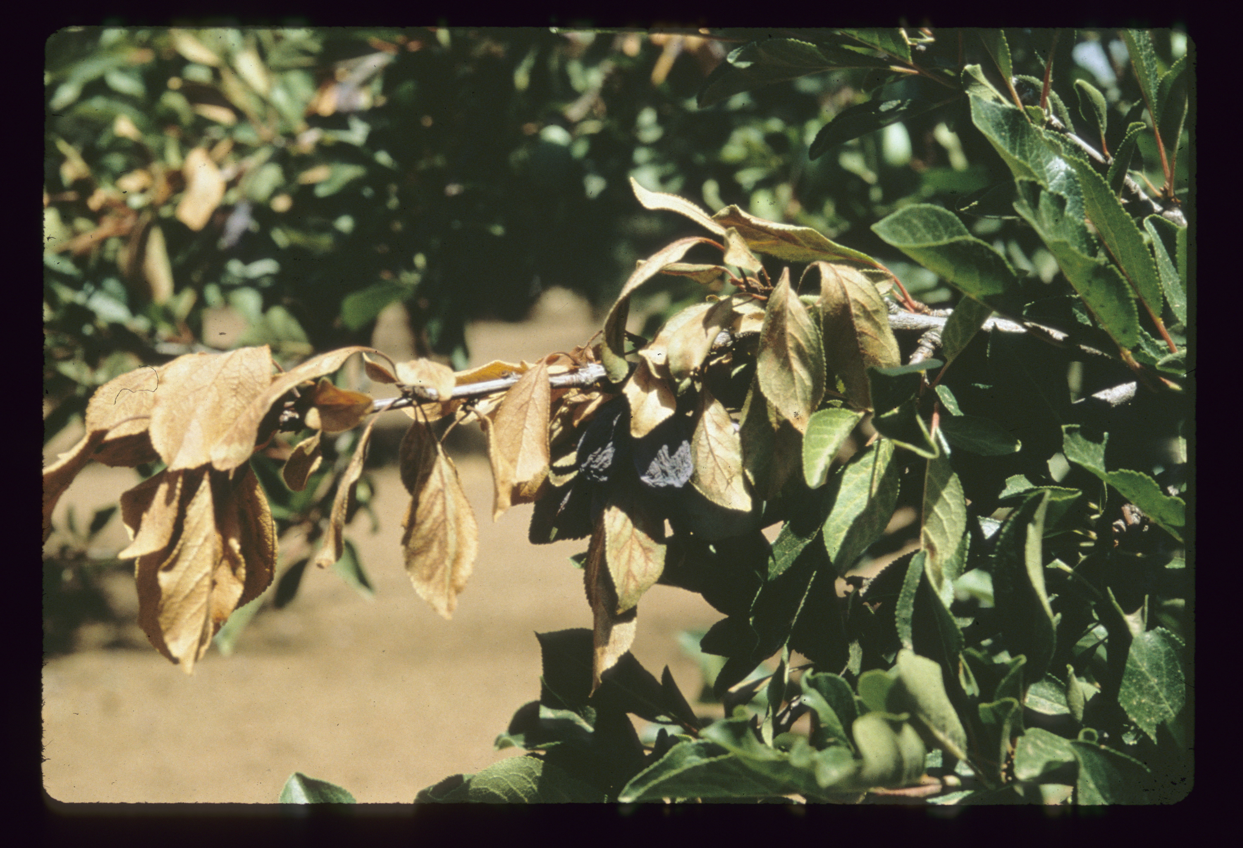

Figure 1.
Blue prune and leaf scorch symptoms showing damaged fruit,
scorched leaves and darkened leaf veins

